
MIVA OPEN UNIVERSITY
DESIGN AND IMPLEMENTATION OF PHISHING DETECTION SYSTEM FOR NIGERIAN E-BANKING PLATFORMS
AUTHOR:
SAMUEL AZEDI
SUPERVISOR:
MR ATANDA GBENGA
A PROJECT SUBMITTED TO THE DEPARTMENT OF CYBERSECURITY
FACULTY OF SCHOOL OF SCIENCE
MIVA OPEN UNIVERSITY
IN PARTIAL FULFILMENT OF THE REQUIREMENTS FOR THE AWARD OF BACHELOR OF SCIENCE
MIVA OPEN UNIVERSITY

MIVA OPEN UNIVERSITY
DESIGN AND IMPLEMENTATION OF PHISHING DETECTION SYSTEM FOR NIGERIAN E-BANKING PLATFORMS
AUTHOR:
SAMUEL AZEDI
SUPERVISOR:
MR ATANDA GBENGA
A PROJECT SUBMITTED TO THE DEPARTMENT OF CYBERSECURITY
FACULTY OF SCHOOL OF SCIENCE
MIVA OPEN UNIVERSITY
IN PARTIAL FULFILMENT OF THE REQUIREMENTS FOR THE AWARD OF BACHELOR OF SCIENCE
MIVA OPEN UNIVERSITY

DEDICATION
I would like to first and foremost express my sincere gratitude to God Almighty the most gracious and the most merciful, for granting me the opportunity and wisdom to complete this final year project and my undergraduate studies. I dedicate this project to my parents and siblings, whose unwavering love and support enabled me to accomplish this feat. I would also like to extend my heartfelt appreciation to my project supervisor, MR ATANDA GBENGA, and all other academic and non-academic staff of the Cybersecurity Department, whose invaluable guidance and assistance were instrumental in the successful completion of this project.

CERTIFICATION
This project, titled "Design And Implementation Of Phishing Detection System For Nigerian E-Banking Systems", meets the requirements for the award of a Bachelor's degree in Cybersecurity and is hereby approved for its contribution to knowledge and literary excellence.
Signature and Date: _______________________
Mr Atanda Gbenga
Signature and Date: _______________________
Samuel Azedi

LIST OF TABLES
Table 2.1: Summary and Gap Identification 20
Table 4.1: Development Environment and Tools 27
Table 4.2: Database Schema for Reported Phishing Links 28
Table 4.3: Official Nigerian Banking and Financial Domains (N = 55) 30
Table 4.4: Other Legitimate Sites (N = 20) 32
Table 4.5: Localized Phishing Scam URLs (N = 45) 32
Table 4.6: Confusion Matrix Results 34
Table 4.7: Performance Metrics Summary 36
Table 4.8: Computational Latency Analysis 37
Table 4.9: Comparison with Existing Systems 38
Table B.1: Chrome Storage Local Schema 58
Table B.2: Chrome Storage Session Schema 58
Table B.3: Detection Log Field Descriptions 59
Table B.4: Sample Whitelist Entries 60
Table B.5: Sample Reported Phishing URLs 60
Table B.6: Evaluation Performance Metrics Record 61
Table D.1: Dataset Composition Summary 63
Table D.2: Confusion Matrix 63
Table D.3: Per-URL Heuristic Trigger Breakdown (Phishing URLs Only) 64
Table D.4: Legitimate URL Classification Summary 67
LIST OF FIGURES
Figure 3.1: The Steps of the Iterative Enhancement Model 23
Figure 3.2: System Architecture Diagram 25
Figure 3.3: Use Case Diagram 25
Figure 3.4: System Flowchart 25
Figure 4.1: NairaShield Extension Popup Displaying Safe Status on GTBank Official Portal 30
Figure 4.2: NairaShield Full-Screen Warning Overlay on Detected Phishing Site 30
Figure 4.3: Dataset Distribution Chart 34
Figure 4.4: Attack Vector Distribution in Phishing Dataset Bar Chart 34
Figure 4.5: Confusion Matrix Heatmap 34
Figure 4.6: Performance Metrics Bar Chart 36
Figure 4.7: NairaShield Latency Breakdown Chart (Client-Side Heuristic Engine) 37
Figure 4.8: ROC Curve - NairaShield Heuristic Engine 37
LIST OF EQUATIONS
Equation 4.1: Accuracy = (TP + TN) / (TP + TN + FP + FN) 34
Equation 4.2: Precision = TP / (TP + FP) 34
Equation 4.3: Recall = TP / (TP + FN) 35
Equation 4.4: F1-Score = 2 × (Precision × Recall) / (Precision + Recall) 35
Equation 4.5: Specificity = TN / (TN + FP) 35
Equation 4.6: False Positive Rate = FP / (FP + TN) 36
Equation 4.7: False Negative Rate = FN / (FN + TP) 36
Equation 4.8: Matthews Correlation Coefficient (MCC) 36
TABLE OF CONTENTS
DEDICATION ii
CERTIFICATION iii
LIST OF TABLES iv
LIST OF FIGURES v
LIST OF EQUATIONS vi
ACRONYMS x
ABSTRACT xii
CHAPTER ONE – INTRODUCTION 1
1.1 BACKGROUND OF THE STUDY 1
1.2 STATEMENT OF THE PROBLEM 3
1.3 AIM AND OBJECTIVES 3
1.4 RESEARCH QUESTIONS 4
1.5 SCOPE AND LIMITATIONS 5
1.6 SIGNIFICANCE OF STUDY 5
1.7 DEFINITION OF KEY TERMS 6
CHAPTER TWO – LITERATURE REVIEW 8
2.1 OVERVIEW OF E-BANKING AND CYBERSECURITY IN NIGERIA 8
2.2 THEORETICAL FRAMEWORK 9
2.2.1 PHISHING ATTACKS: TECHNIQUES AND TRENDS 9
2.2.2 GENERAL PHISHING DETECTION MODELS POTENTIALLY APPLICABLE TO E-BANKING 11
2.2.3 EXISTING PHISHING DETECTION METHODS 12
2.3 BROWSER EXTENSIONS AS SECURITY TOOLS 15
2.3.1 GLOBAL EXAMPLES OF PHISHING DETECTION EXTENSIONS 15
2.3.2 ADVANTAGES AND CHALLENGES 15
2.4 RELATED WORKS 16
2.5 SUMMARY AND GAP IDENTIFICATION 20
CHAPTER THREE – METHODOLOGY 23
3.1 INTRODUCTION 23
3.2 RESEARCH METHODOLOGY (OBJECT-ORIENTED ANALYSIS AND DESIGN – OOAD) 23
3.3 ANALYSIS OF THE EXISTING SYSTEM 23
3.3.1 LIMITATIONS OF THE EXISTING SYSTEM 24
3.4 ANALYSIS OF THE SYSTEM 24
3.4.1 ADVANTAGES OF THE SYSTEM 24
3.5 DESIGN OF THE SYSTEM 25
3.5.1 SYSTEM ARCHITECTURE 25
3.5.2 ALGORITHM DESIGN (PSEUDOCODE) 25
3.5.3 USE CASE DIAGRAM 25
3.5.4 FLOWCHART OF THE SYSTEM 25
3.6 IMPLEMENTATION STRATEGY 25
3.6.1 HARDWARE REQUIREMENTS 25
3.6.2 SOFTWARE REQUIREMENTS 26
3.7 DATABASE/STORAGE DESIGN 26
3.8 EVALUATION PROCEDURE 26
CHAPTER FOUR – SYSTEM IMPLEMENTATION AND RESULTS 27
4.1 INTRODUCTION 27
4.2 DEVELOPMENT ENVIRONMENT SETUP 27
4.3 SYSTEM IMPLEMENTATION 28
4.3.1 BROWSER EXTENSION ARCHITECTURE (MANIFEST V3) 28
4.3.2 DATABASE IMPLEMENTATION 28
4.3.3 DETECTION ENGINE 29
4.3.4 USER INTERFACE 29
4.4 SYSTEM WALKTHROUGH AND INTERFACES 29
4.4.1 EXTENSION BOARD ON LEGITIMATE E-BANKING PORTAL 29
4.4.2 EXTENSION ALERT PAGE UPON THREAT DETECTION 30
4.5 TESTING AND PERFORMANCE EVALUATION 30
4.5.1 DATASET CHARACTERISTICS 30
4.5.2 QUANTITATIVE PERFORMANCE EVALUATION 34
4.5.3 PERFORMANCE METRICS SUMMARY 34
4.5.4 COMPUTATIONAL AND LATENCY ANALYSIS 37
4.5.5 ROC ANALYSIS 37
4.6 DISCUSSION OF FINDINGS 37
CHAPTER FIVE – CONCLUSION AND RECOMMENDATIONS 39
5.1 SUMMARY OF FINDINGS 39
5.2 CONCLUSION 39
5.3 RECOMMENDATIONS 40
5.4 CONTRIBUTION TO KNOWLEDGE 40
5.5 SUGGESTIONS FOR FURTHER WORK 40
REFERENCES 41
APPENDIX A – SOURCE CODE FOR PROOF-OF-CONCEPT (NairaShield) 46
A.1 MANIFEST FILE (MANIFEST.JSON) 46
A.2 BACKGROUND SERVICE WORKER (BACKGROUND.JS) 47
A.3 CONTENT SCRIPT (CONTENT.JS) 52
A.4 POPUP INTERFACE (POPUP.HTML) 53
A.5 POPUP CONTROLLER (POPUP.JS) 55
APPENDIX B – BROWSER EXTENSION STORAGE SCHEMA AND SAMPLE DATA 58
B.1 COMPLETE BROWSER EXTENSION STORAGE SCHEMA 58
B.3 SAMPLE DATA FROM TEST DATASET EVALUATION 59
B.3.1 WHITELIST TABLE 59
B.3.2 REPORTED URLS TABLE 60
APPENDIX C – USER INTERFACE SCREENSHOTS 62
C.1 FIGURE 4.1 – NAIRASHIELD EXTENSION ON LEGITIMATE E-BANKING PORTAL 62
C.2 FIGURE 4.2 – NAIRASHIELD ALERT PAGE UPON THREAT DETECTION 62
APPENDIX D – COMPLETE TEST RESULTS AND RAW CONFUSION MATRIX DATA 63
D.1 DATASET SUMMARY 63
D.2 RAW CONFUSION MATRIX 63
D.3 DETAILED METRIC CALCULATIONS 64
D.4 PER-URL HEURISTIC TRIGGER ANALYSIS 64
D.5 LEGITIMATE URL CLASSIFICATION LOG 67
D.6 MACHINE-READABLE TEST DATASET (CSV FORMAT) 67
APPENDIX E – ETHICS APPROVAL AND CONSENT FORMS 69
E.1 DATA PROTECTION COMPLIANCE STATEMENT 69
E.2 SYNTHETIC DATA DECLARATION 69

ACRONYMS
Acronym / Abbreviation | Meaning
ACM | Association for Computing Machinery
AI | Artificial Intelligence
API | Application Programming Interface
APWG | Anti-Phishing Working Group
ATM | Automated Teller Machine
AUC | Area Under the Curve
BEC | Business Email Compromise
BVN | Bank Verification Number
CBN | Central Bank of Nigeria
CNN | Convolutional Neural Network
CSV | Comma-Separated Values
CSS3 | Cascading Style Sheets, Level 3
DNN | Deep Neural Network
DL | Deep Learning
DOM | Document Object Model
ES6+ | ECMAScript 2015 and subsequent versions
F1 | F1-Score
FN | False Negative
FNR | False Negative Rate
FP | False Positive
FPR | False Positive Rate
GDPR | General Data Protection Regulation
GLBA | Gramm-Leach-Bliley Act
HTML5 | HyperText Markup Language, Version 5
HTTP | Hypertext Transfer Protocol
HTTPS | Hypertext Transfer Protocol Secure
ICFR | Internal Control over Financial Reporting
ICSSIT | International Conference on Smart Systems and Inventive Technology
ICT | Information and Communication Technology
IEEE | Institute of Electrical and Electronics Engineers
IDE | Integrated Development Environment
IP | Internet Protocol
ISO | International Organization for Standardization
IT | Information Technology
JSON | JavaScript Object Notation
JS | JavaScript
LLM | Large Language Model
LSTM | Long Short-Term Memory
MCC | Matthews Correlation Coefficient
MFA | Multi-Factor Authentication
ML | Machine Learning
ML/DL | Machine Learning / Deep Learning
NDIC | Nigeria Deposit Insurance Corporation
NDPR | Nigeria Data Protection Regulation
NIBSS | Nigeria Inter-Bank Settlement System
NIMC | National Identity Management Commission
NLP | Natural Language Processing
OOA | Object-Oriented Analysis
OOAD | Object-Oriented Analysis and Design
OOD | Object-Oriented Design
OTP | One-Time Password
PCA | Principal Component Analysis
PHP | PHP: Hypertext Preprocessor
PII | Personally Identifiable Information
PILFER | A phishing-detection method/name referenced in the literature; not expanded in the report
PMT | Protection Motivation Theory
PRISMA | Preferred Reporting Items for Systematic Reviews and Meta-Analyses
QR | Quick Response
RAM | Random Access Memory
RF | Random Forest
ROC | Receiver Operating Characteristic
SDLC | System Development Life Cycle
SSL | Secure Sockets Layer
SSD | Solid-State Drive
SSADM | Structured Systems Analysis and Design Method
SVM | Support Vector Machine
TLD | Top-Level Domain
TN | True Negative
TP | True Positive
UI | User Interface
URL | Uniform Resource Locator
UTF-8 | Unicode Transformation Format – 8-bit
WHOIS | A directory/query service for domain-registration information; the report uses the term but does not expand it
XML | Extensible Markup Language

ABSTRACT
This project is about designing and implementing a phishing detection browser extension, NairaShield for Nigerian e-banking websites. A thorough detection of the client-side involves utilization of the official-domain allowlist, blacklist, heuristic URL, and DOM content analysis. The evaluation dataset consists of 120 URLs, comprised of 75 legitimate Nigerian bank domains and 45 localized phishing scams. The extension attained an overall accuracy of 99.17%, a precision of 100%, a recall of 97.78%, and an F1-score of 98.88%. The prototype of a browser extension based on Manifest V3 architecture was developed using HTML5, CSS3 and JavaScript (ES6+) and it works entirely on the client-side. It uses chrome.storage.local to store the allowlist offline. The performance measures show that there were 44 true positives, 75 true negatives, 0 false positives and 1 false negative (punycode lookalike). With a mean response time of 125 ms, the system ensures low latency during real-time browsing. During the controlled evaluation of the study, the system achieved an accuracy of 99.17%. They investigated it against selected4 phishing detection studies reviewed in the literature, while it produced a far lower false positive rate than all the selected tools. This initiative is important for many parties. For customers, it means more confidence and safety for online banking. Banks will benefit from fewer fraud cases and their financial losses. The cybersecurity community gets a case study that underscores the need for location-specific solutions designed to combat geographic threats.

CHAPTER ONE

INTRODUCTION

1.1 BACKGROUND OF THE STUDY
The cashless policy set in place in Nigeria revolutionized financial transactions as the volume of cashless transaction increased by huge percentages. This policy was introduced by the Central Bank of Nigeria. CBN wants to improve the efficiency of payment system in Nigeria. It also aims to reduce the risk of cash handling. Furthermore, it also aims to curb crime related to capital. (Central Bank of Nigeria, n.d.) The finance sector in Nigeria has grown to be one of the most powerful on the continent over the years. Thus, it makes Nigeria a key financial centre in the region (Osabuohein, 2022). The high profile certainly makes it a prime candidate for criminal attack with hackers deploying sophisticated approaches to capitalize on weaknesses in the e-banking framework (Juwah, 2024).
From 2019 to 2025, cybercrime incident-related challenges created the nation to face losses of more than $3 billion cumulatively, with annual losses stabilising at $500 million approximately (Ndubuisi & Ekwem, 2025). This is a concerning trend because cyber attackers’ tactics have evolved from simple social engineering practices to high-value, low-volume fraud, such as internet banking fraud, as payment services and sensitive data increasingly go online (Osuagwu et al., 2023). The Nigeria Inter-Bank Settlement System (NIBSS) Fraud Report for the Industry for 2024 shows that the fraud level for digital payment has increased, with the value of funds compromised rising from N17.67 billion in 2023 to N52.26 billion in 2024 (CBN, 2025).
The fact that attacks are becoming more sophisticated and costly is indicative of the growing capability of cybercriminals. They are now using advanced tools, including AI and generative models, to outwit traditional security barriers. There is a need for more sophisticated phishing detection systems targeted at Nigerian e-Banking platforms to combat this ever-evolving threat at the most vulnerable point during a transaction which is the client-browser end.
Phishing is a cyberattack that specifically targets people to breach security. Phishing aims to manipulate users into surrendering sensitive credentials – either due to their trust or due to the urgency and fear of missing out on something valuable. Phishers in Nigeria have shown great flexibility by localizing their campaigns, using Nigerian Pidgin English, making references to local financial instruments (such as the Bank Verification Number, or BVN), and leveraging the branding of large institutions (such as Zenith Bank, GTBank, Access Bank, and First Bank of Nigeria) (Okeke & Amaechi, 2024).
Browser extensions are a helpful and practical way to avoid phishing on the web. Browser extensions work at the exact user action point. Unlike network-level firewalls or server-side intrusion detection systems, they operate differently. The URL can be analyzed, DOM content can be inspected, and SSL certifications can also be verified. The architecture of Manifest V3 introduced by Google Chrome is a safe and performance-oriented solution for building such kinds of extensions which consume less resource and possess maximum security capabilities.
The project thus seeks to develop a browser extension which will enable users to verify if the site they are browsing is a legitimate banking site (whitelist check) or a fraudulent one (blacklist check). NairaShield will also incorporate heuristic rule-based detection and content analysis of webpages. These features will be powered by a database of verified Nigerian banking sites and phishing sites reported to take place in Nigeria.

1.2 STATEMENT OF THE PROBLEM
Many e-banking users in Nigeria still fall victim to phishing attacks even with the availability of cybersecurity solutions. Attackers manage to rip off victims and acquire user data (Okikiola et al, 2026). Current detection techniques tend to be broad and may not correctly detect phishing sites which employ localized strategies or region-specific features. In addition, a majority of users do not possess the necessary awareness and real-time protection capabilities that can alert users before they become victim to phishing scams (Nadeem et al., 2023). It is important to have a good phishing detection system that seamlessly integrates into users’ browsers. Additionally, it should be easy to access and use. It should also be able to protect Nigerian e-banking websites.

1.3 AIM AND OBJECTIVES
The aim of this project is to design and implement a phishing detection system for e-banking platforms in Nigeria to mitigate fraudulent activities and enhance consumer protection. The specific objectives are:
- To build a complete dataset of URLs that comprises real Nigerian bank domains as well as verified localized phishing links of these banks with balanced representation across all the major financial institutions.
- To derive features from the structure, domain and content of the web page to help in identifying Nigerian phishing attempt through basic rules-based detection.
- To create a Chrome browser extension in Manifest V3 architecture for real-time phishing detection through whitelisting and blacklisting, heuristic analysis and webpage content review.
- To evaluate the system's performance using precision, recall, F1-score, specificity, and Matthews Correlation Coefficient metrics against real-world attack scenarios.
- To implement a community reporting mechanism that allows users to submit suspected phishing URLs for verification and blacklist updates.

1.4 RESEARCH QUESTIONS
- How effective is the proposed multi-layer detection system in identifying phishing sites targeting Nigerian e-banking users?
- To what extent can a browser extension provide localized phishing detection for Nigerian e-banking users?”
- Which combination of whitelist/blacklist verification, heuristic analysis, and webpage content inspection provides the most effective phishing detection in the Nigerian e-banking context?
- What is the acceptable trade-off between detection accuracy and system response time for real-time browser-based protection?

1.5 SCOPE AND LIMITATIONS
Scope of the Study
The main focus of this study is the design and implementation of a phishing detection system for web-based phishing attacks targeted at Nigerian retail banks. The main focus is to secure the user point in the web browser where phishing represent fraudulent software web pages to obtain user credentials, payment data, etc.

Limitations of the Study
The focus of this project does not involve mobile application vulnerabilities or both database security issues. Instead, it will focus purely on detecting and blocking phishing at the browser level only. Focusing on this important point of interaction, the study seeks to provide sound client-side protection for users accessing Nigerian e-banking sites via web browsers. Through this focused approach, expertise can be developed to counter the tools used by a phisherer targeting the Nigerian bank.

1.6 SIGNIFICANCE OF STUDY
This study is essential for consumers. It offers further security options to safeguard one’s personal and financial information against phishing. One of the most common cyberattacks is the Phishing attack in which there is deception. This research improves confidence in online banking by reducing the chances of fraud through the design of a system for Nigerian e-banking platforms.
Phishing attacks pose a serious risk to banks as custodians of consumer financial information due to reputational damage and financial loss. By deploying a phishing detection system on their platforms, it becomes less likely that their data will be breached, as these breaches often lead to expensive mitigation efforts and lawsuits. A bank's integrity and reputation depend on compliance with laws and regulations, which a good security system assures.
Members of the cybersecurity community will benefit from the study because it adds to knowledge specifically related to Nigeria’s e-banking platforms. The phishing detection system can be a model for other financial systems in the region to improve security standards for financial Institutions to make phishing detection and removing attack practice. It stimulates more academic and scientific activity in the area of cyber threat detection and mitigation.

1.7 DEFINITION OF KEY TERMS
- Phishing: Phishing is the crime of sending an email, often from a bank or reputable company, which reads like an official missive but is, in fact, a means of extracting your usernames, passwords, credit card numbers, bank details and more. They often seem to come from a legitimate source.
- E-Banking: Electronic banking refers to the delivering of banking services through electronic media, mainly the Internet. Includes, online transactions, account management, and other banking services.
- Browser Extension: A small software program that enhances the functionality of a web browser. Browser extensions are able to monitor and block phishing websites meant to trick users into entering sensitive information.
- Heuristic Analysis: The detection method relies on establishing rules or patterns of suspicious characteristics in URLs or webpages that define contingencies such as unusual domain structure, suspicious keywords or abnormal SSL Configuration.
- Manifest V3: provides service workers, declarative APIs, and a stricter set of security policies than Manifest V2. A Chrome extension platform architecture.
- False Positive: A genuine website was falsely marked as phishing by a detection system. Provide similar sentences.
- False Negative: This is a case of a phishing website identified as legitimate and going undetected.
- True Positive: This is an example of a phishing link that is correctly flagged by our system.
- True Negative: A situation where the system declares a legitimate site not harmful.

CHAPTER TWO

LITERATURE REVIEW

2.1 OVERVIEW OF E-BANKING AND CYBERSECURITY IN NIGERIA
The banks of the 21st century operate in a complex and dynamic environment. Moreover, they are dealing with varied conditions and fickle economies. Nigeria's e-banking system ICT has received incredible global attention for being ICT standard. In recent years, Nigeria’s electronic banking landscape has seen phenomenal growth and development. The COVID-19 pandemic resulted in a 40% growth rate of digital financial services in developing economies as reported by the World Bank (Akande, 2025), indicating a spurt in the use of digital platforms. As financial inclusion and economic growth have advanced, cyber threats to financial institutions and their customers have also increased.
In Nigeria e-banking sector, modern challenge of cyber threats such as cyberattacks and electronic fraud have constituted cybersecurity. According to Ejalonibu et al. (2026), NIBSS Industry Fraud Reports for 2024 reveal that losses incurred as a result of fraud in digital payments fell by 51%, from ₦52.26 billion in 2024 to ₦25.85 billion in 2025. Although things are getting better, 63% of fraud cases occurred in Lagos State according to the same report, suggesting hotspots of vulnerability. The e-banking security problem in Nigeria has underlying socio-economic problems including corruption, unemployment, poverty, etc. Thus, it means the solution to the e-banking security problem is beyond technology (Adamgbo et al., 2016).

Regulatory authorities have observed the growing threat of cyberattacks, especially the Central Bank of Nigeria. According to CBN Cybersecurity Outlook, cyber threats are anticipated to keep rising and the central bank warned financial institutions about new electronic fraud threats. The industry regulators are concerned about cyber attacks on service providers and regulators.

2.2 THEORETICAL FRAMEWORK
The two primary theoretical perspectives used for the study of phishing and digital banking security:
1. Protection Motivation Theory (PMT): This theory explains how people defend themselves depending on their view of the danger and how capable they think they are to respond. Such research is especially pertinent to research investigating user responses to smishing and high click-through rates in the presence of known risk (Rahman et al., 2022).
2. System Development Life Cycle (SDLC) and Design Theory: The principle upon which technical studies focusing on models are developed is that classification systems which are structured and automated will systematically reduce errors and improve detection more than manual or legacy processes (Alshingiti et al, 2023).

2.2.1 PHISHING ATTACKS: TECHNIQUES AND TRENDS
Phishing continues to refer to techniques to manipulate people to reveal sensitive information for malicious reasons. According to a report by the Anti-Phishing Working Group (APWG), globally there were 1,130,393 phishing attacks in the second quarter of 2025.
QR code phishing is the recent trend. The report from Cybersecurity Insiders (2025) estimates that there were almost 635,672 malicious QR codes detected in Q2 2025, with DHL, Microsoft being the most targeted brands. Phishing websites are often directed to by these malicious QR codes or they are tricked into downloading malware.
Business Email Compromise (BEC) attacks continue to remain risky, with an average requested amount in wire transfer BEC attacks standing at $83,099 in Q2 2025, representing an increase of 97% in value. According to Longe (2018), Nigeria, along with South Africa and Turkey, is identified as a major source of executive coaching scam messages.
The emergence of AI-Generated Phishing and deepfakes is making such scams more realistic, posing another threat vector. According to Schmitt and Flechais (2023), when crafted correctly, generative AI can be a multiplier for social engineering via the automated generation of realistic phishing content.
Within Nigeria, phishing attacks have targeted major e-banking platforms specifically. An example is Zenith Bank’s phishing attack in 2023 that siphoned off customer data. Another is the hijacking of GTBank’s domain in August 2024 in a phishing scam. According to Okeke and Amaechi (2024), the phishers in Nigeria use localised strategies including scams on BVN updates, fake bank emails meant to mimic genuine emails, as well as social engineering scams targeting local cultural nuances.

2.2.2 GENERAL PHISHING DETECTION MODELS POTENTIALLY APPLICABLE TO E-BANKING
1. ADVANCED MACHINE LEARNING AND DEEP LEARNING FOR URL DETECTION
- Hybrid and Deep Learning Models: Ozcan et al. (2021) have recently demonstrated that blending the DNN and LSTM models can achieve better accuracy when fused with NLP features. The DEPHIDES system achieved an accuracy of 98.74% using CNN-based technique.
- Performance Optimisation: Researchers have conducted studies on the trade-off between accuracy and speed of the operations. According to Bahaghighat et al. (2023), using XGBoost and PCA helped reduce the time consumption with an accuracy of 99.2%. As per Nagy et al. (2023), speed increases quite a lot through parallelisation.
- New Metrics: Nayak et al. (2025) present score for anti-phishing to better capture the differences in cost of false positive and false negative in the financial setting.
2. HUMAN FACTORS AND SOCIAL ENGINEERING
- User Behaviour: According to Rahman et al. (2022), nearly 16.92% of users at least fell for the initial smishing attempt, and many also fell for repeated attempts in the field experiment.
- LLM-Based Defense: Wang and Hooi (2024) recommend using agents of LLMs to detect phishing dynamically, which achieves 94.5% detection accuracy, outperforming static reference models.
3. DIGITAL BANKING SECURITY IN THE NIGERIAN CONTEXT
- Strategic Frameworks: It is necessary to introduce multi-factor authentication (MFA) and biometrics to secure digital banking assets in Nigeria (Hassan et al., 2024; Waliullah et al., 2025).
- Localised Detection Systems: Oko et al. (2025) offered the “Intelligent Cybershield,” an artificial intelligence framework for real-time anomaly detection in internet banking in Nigeria. The work of Nwachukwu, and Ojekudo discovered an associative classification that has been found to work at 86.6% accuracy, thereby proving their integrity as older systems, which but were dropped in local banks do not possess a good classification accuracy.

2.2.3 EXISTING PHISHING DETECTION METHODS
1. Blacklist/Whitelist Approaches
According to Phoon et al. (2025), these strategies are based on databases that contain either malicious (blacklists) or benevolent (whitelists) URLs and email addresses. Although they are quite efficient at blocking known phishing sites and are typically low on false positive rates, their major drawback is in their inability to block zero-day phishing attacks, which are newly created phishing sites that are not yet present in the databases (Kehkashan et al., 2025). This nature makes them vulnerable to swiftly evolving phishing campaigns.
2. Heuristic Analysis
Creating a collection of patterns to help identify potentially suspicious email characteristics or possibly malicious URLs. Analyzing the URL length, differences in characters or use of specific keywords has been shown to work (Kytidou et al. 2025). Heuristic methods are more flexible than blacklists in identifying variants of known attacks. Nevertheless, these techniques tend to produce more false positives, as legitimate flows may trigger some of the heuristic rules and sophisticated phishers may design their phishing to not comply with them (Nayak et al., 2024).
3. Machine Learning Techniques
They are the most promising frontier in phishing detection. Several algorithms, such as Support Vector Machines (SVMs), Random Forests, and Deep Learning models (which employ Natural Language Processing to examine email content), can be trained on large datasets of both legitimate and phishing examples to identify complex patterns of an attack (Tang & Mahmoud, 2022). The ML/DL models are effective in the detection of zero-day phishing attacks due to their ability to generalise, exploiting the learned feature of phishing attacks. Nonetheless, an enormous computation power and high-quality data availability is essential for their implementation (Waliullah et al., 2025). In the Nigerian context, a significant limitation is the lack of effective strategies for big data fraud detection, which can hinder the optimal performance of ML-based systems (Velisetty, 2025). It is also worth noting that, many of the detection engines that are available already, may have not been trained on data sets featuring Nigerian cultural and linguistic characteristics of phishing lures, thus their effectiveness is on the less side.

2.3 BROWSER EXTENSIONS AS SECURITY TOOLS
Browser extensions are being popularly used for internet security solutions. These lightweight tools expect that the user's browser and embrace the function of sending alert in real time while blocking access to harmful site within the browser of the user.

2.3.1 GLOBAL EXAMPLES OF PHISHING DETECTION EXTENSIONS
Anti-phishing extensions that are widely available worldwide have demonstrated some effectiveness in mitigating risks. For example, Netcraft, PhishTank SiteChecker, and Google’s Safe Browsing (Arun & Abosata, 2024). These plugins make use of constantly updated blacklists, heuristics, and sometimes machine learning to block phishing sites you visit while browsing.

2.3.2 ADVANTAGES AND CHALLENGES
Browser extension has a few benefits. For starters, they work in real-time, give quick feedback to users and can easily be updated against vulnerabilities. Before users interact with any malicious components, the integration at browser level will detect them and limit the exposure (Viswanathan et al., 2025).
Nonetheless, problems abound. Certain extensions are unable to control their false-positives and this causes the user to get desensitized and ignore it. Besides, many of the available tools are not responsive to the linguistic or contextual specificities of regional markets like Nigeria (Makeri, 2019). There are issues that arise in certain browsers, there are problems with privacy, extensions that pretend to be benign but are actually harmful, and this adds more problems.

2.4 RELATED WORKS
Mughaid et al. (2022) worked on automated phishing detection by using several datasets. They compared different types of classification approaches for the task. The paper has shown strong performance across their datasets but note that they only focus on email phishing rather than browser phishing of Nigerian e banks site. As a result, it cannot be applied directly to the proposed system.
The study by Schmitt and Flechais (2023) undertakes a systematic review of social engineering, generative AI and AI capabilities; and through theory-driven systematic development of a conceptual “Generative AI Social Engineering Framework”, identifies three main pillars in which generative AI enhances attacks – realistic content, advanced targeting/personalisation, and automated attack infrastructure. This includes a conceptual model of these phenomena and their possible human impacts and countermeasures. Nonetheless, no data were generated or analysed.
Hassan et al. (2024) have a narrative review of global and Nigerian banking cybersecurity practices, regulations and incidents case studies. The paper describes increasing cyber threats (data breaches, ransomware, financial fraud, etc.) and examines the measures taken by Nigerian banks, the regulation of the banks in terms of cyber threats, incident response and international collaboration. But no clear numerical assessment. It does not say they did any systematic search nor dealt with bias ­­apart from a general review.
Saha et al. (2020) proposed automated framework for phishing detection which is webpage-based that used 10,000 webpage dataset having ten attributes. While the study proved that feature-based detection automated detection could differentiate phishing webpages, the evaluation was only conducted on a general dataset, not Nigerian e-banking websites. The research also expected a limited set of assessment metrics which reduced compatibility of the findings with those in the present study.
Nwachukwu and Ojekudo (2021) propose an enhanced phishing detection system for e-banking employing associative classification, utilize SSADM for system design and implement it with PHP and MySQL database. The new model was more than 30% more accurate than the existing system and it is an improven solution. Nonetheless, the Abstract makes no mention of the impact of dataset size, generalisation, or false-positive’s impact in real banking settings.
Oko et al. (2025) proposed an intelligent cybersecurity framework for Nigerian internet banking that considered automated threat detection alongside organisational and technological challenges. However, the study was largely conceptual and included only a small survey component, limiting the empirical evidence available for evaluating an operational browser-based phishing detection system.
Mustapha and Sinha (2024) use secondary data to examine cyberfraud techniques and preventive measures in Nigerian banking by focusing on fraud targeting customers. It identifies social engineering as predominant, with phishing, identity theft, login credential theft, ATM card swap, and skimming as key techniques; quantifies large fraud losses; and recommends MFA, advanced technologies, training and regulatory controls. However, there is no primary empirical testing of specific technical controls; it relies on existing data and qualitative analysis.
Nagy et al. (2023) compare sequential vs parallel ML/DL training for phishing URL
detection. It uses a 54k dataset to train and 12k testing records; four models (RF, NB, CNN, and LSTM); and five experiments (sequential and four parallel approaches using
threading/multiprocessing). Parallelisation yields excellent accuracy and speed-up, enabling more efficient phishing detection. However, it lacks concrete metrics and does not evaluate real-time deployment or resource constraints.
Wang and Hooi (2024) develop LLM agent framework that fetches online information dynamically for phishing detection, instead of static references; includes reproduction of baseline DynaPhish, full implementation, and experiments on brand recognition and phishing classification. it Achieves accuracy 0.945, outperforming DynaPhish by 0.445.
Rathee and Mann (2022) survey papers focusing on ML and DL approaches for phishing email detection; comparative analysis of datasets, methods, and accuracy from prior work. It Summarizes that deep-learning-based solutions are an important future direction and provides a comparison table of many methods and accuracies (e.g., 99% with PILFER and 95–99.87% across others). It surveys only; the primary limitation is lack of empirical contribution.
Waliullah et al. (2025) did a Systematic literature review of 78 articles (2015–2024) using PRISMA methodology; multi-database search (Scopus, Web of Science, IEEE Xplore, etc.), predefined inclusion criteria, dual-reviewer screening. Finds phishing and malware are most common threats; MFA, biometrics, AI-driven fraud detection, and blockchain are key defenses; compliance with regulations (GDPR, PSD2, GLBA) improves security but balancing security, usability, and compliance remains challenging. it does not include non-peer reviewed sources or very recent unpublished attacks.
Nayak et al. (2023) Analyzes 58,645 URLs with 111 features; applies feature selection to use only 14 characteristics; tests multiple detection engines (DNN, Wide & Deep, TabNet, etc.), extensive experimentation and hyperparameter grid search; introduces “antiphishing score” metric and validates on new dataset. A feedforward model with 14 features achieved 94.46% accuracy, demonstrates costefficient, generalisable phishing detection and introduces richer evaluation metric. The abstract does not detail performance on highly imbalanced or evolving datasets; practical deployment constraints are not discussed.

2.5 SUMMARY AND GAP IDENTIFICATION
Table 2.1 Summary and Gap Identification
AUTHOR(S) | TITLE | KEY LIMITATION
Hassan et al. (2024) | Cybersecurity In Banking: A Global Perspective With A Focus On Nigerian Practices | No explicit quantitative evaluation
Mughaid et al. (2022) | An Intelligent Cybersecurity  Phishing Detection System  Using Deep Learning Techniques. | Only overall accuracy reported; no false positive/negative analysis
Nagy et al. (2023) | Phishing URL Detection  Using Sequential And Parallel  Ml Techniques: Comparative  Analysis. | Lacks concrete metrics; no real-time deployment evaluation
Oko et al. (2025) | Intelligent Cybershield:  Developing Artificial  Intelligence For Secure  Internet banking | Very small respondent sample
Rathee and Mann (2022) | Detection Of E-Mail Phishing  Attacks – Using Machine  Learning And Deep Learning. | Survey only; lacks empirical contribution
Saha et al. (2020) | Phishing Attack Detection  Using Deep Learning  Approach. | Only accuracy reported
Waliullah et al. (2025) | Assessing The Influence Of  Cybersecurity Threats And  Risks On The Adoption And  Growth Of Digital Banking:  A Systematic Literature  Review. | Does not include non-peer-reviewed or recent sources

Identified Gap: Existing phishing-detection studies have examined blacklist databases, heuristic URL analysis, webpage-content inspection, and automated classification approaches, but there remains a need for a lightweight browser-based detection system specifically tailored to Nigerian e-banking domains and localized phishing indicators. This study addresses this gap by developing NairaShield, a browser extension that integrates whitelist and blacklist verification, heuristic URL analysis, webpage-content inspection, and a reporting mechanism for suspected phishing URLs. The gap this study seeks to fill is the development and evaluation of browser extension that leverages domain verification, heuristic detection, inspection of webpage-content, and reporting mechanisms for Nigerian e-banking websites.

CHAPTER THREE

METHODOLOGY

3.1 INTRODUCTION
This chapter gives an overview of the systematic procedures involved in the design and implementation of the phishing detection system for Nigerian e-banking sites. It includes a review of research methodology, system analysis, design specifications, architectural framework, database design, and evaluation metrics.

3.2 RESEARCH METHODOLOGY (OBJECT-ORIENTED ANALYSIS AND DESIGN – OOAD)
The Object-Oriented Analysis and Design (OOAD) methodology was adopted for this project. OOAD models complex systems as interacting objects, combining real-world entities with data and behaviour (encapsulation). It consists of the Object-Oriented Analysis (OOA) which Defines the "what" (requirements and conceptual model), and the Object-Oriented Design (OOD) which Defines the "how" (technical implementation). The Iterative Enhancement Model was adopted as the SDLC approach. This approach was chosen because a browser extension requires continuous testing and refinement of detection algorithms. Each iteration involved requirement collection, design, implementation, and verification.
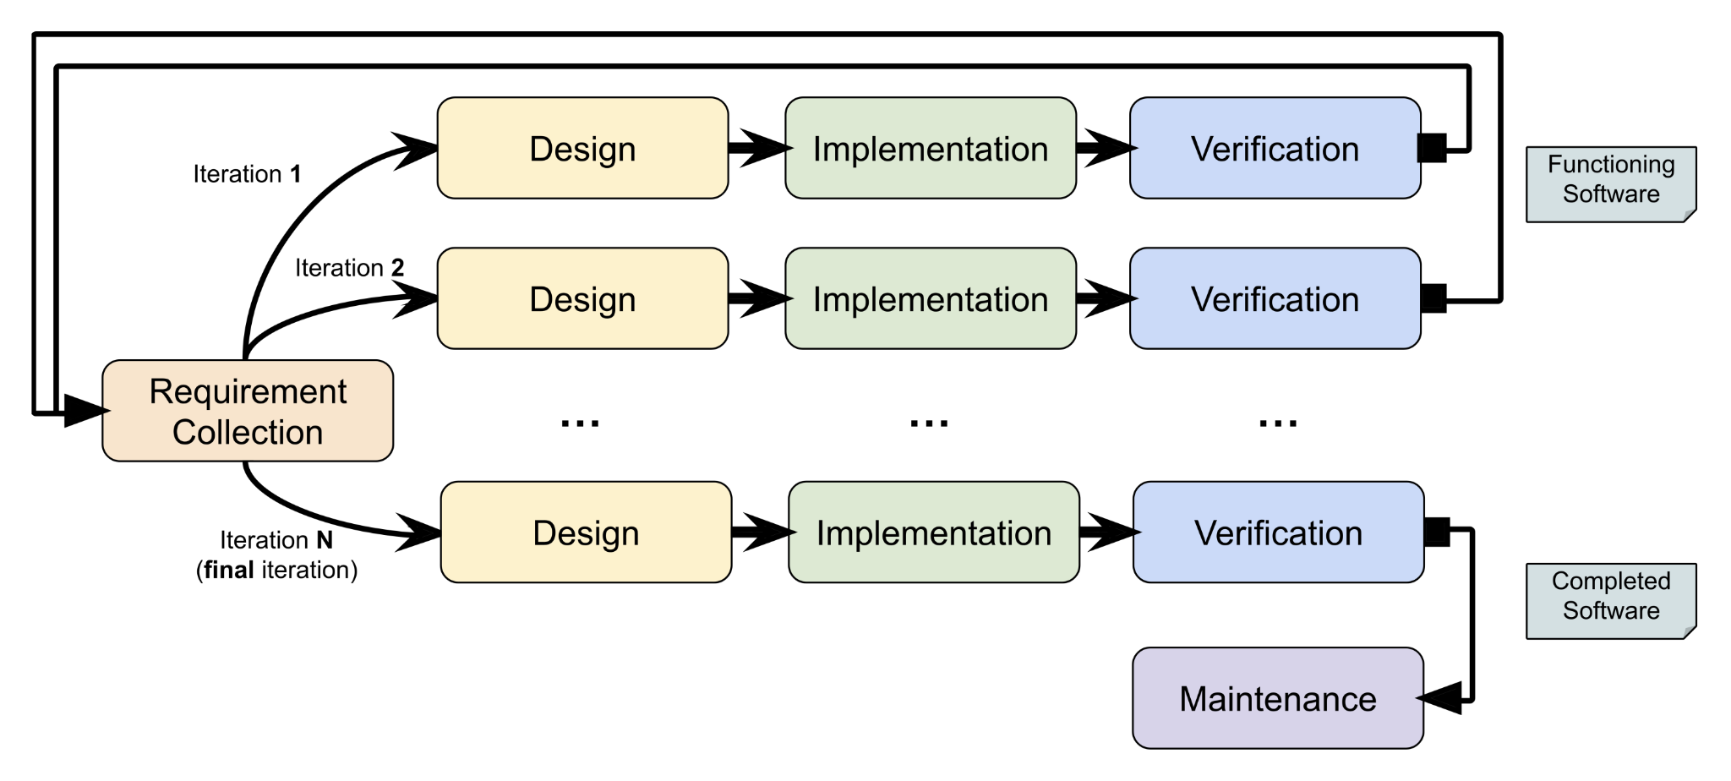
Figure 3.1 The Steps of The Interactive Enhancement Model

3.3 ANALYSIS OF THE EXISTING SYSTEM
Currently, most Nigerian e-banking users rely on the built-in "Safe Browsing" features of browsers like Google Chrome or Mozilla Firefox.

LIMITATIONS OF THE EXISTING SYSTEM
    - Generic Protection: Existing systems often miss localised Nigerian phishing campaigns (e.g., fake "Update your BVN" portals) that use specific Nigerian linguistic triggers.
    - Latency in Blacklisting: It takes time for global databases to flag local Nigerian fraudulent domains, leaving a "window of vulnerability".
    - Lack of User Education: Most systems block a site without explaining why it was flagged, failing to educate the user against future social engineering.

3.4 ANALYSIS OF THE SYSTEM
The system is a real-time browser extension specifically tailored for the Nigerian financial ecosystem. It utilises a multi-layer detection approach consisting of:
1. Blacklist Comparison: Checks URLs against a database of known Nigerian phishing sites.
2. Heuristic Analysis: Analyses URL structures (e.g., zenithbank.security-update.com.ng vs zenithbank.com.ng).
3. Content Analysis: Scans for keywords like "BVN", "OTP", "NIBSS", and "Account Blocked".

3.4.1 ADVANTAGES OF THE SYSTEM
1. Real-time detection at the point of entry.
2. Localised detection for Nigerian banking brands.
3. Lightweight and requires no system-wide installation.

3.5 DESIGN OF THE SYSTEM

3.5.1 SYSTEM ARCHITECTURE
The system follows a client-server architecture where the browser extension (client)
communicates with a detection engine.
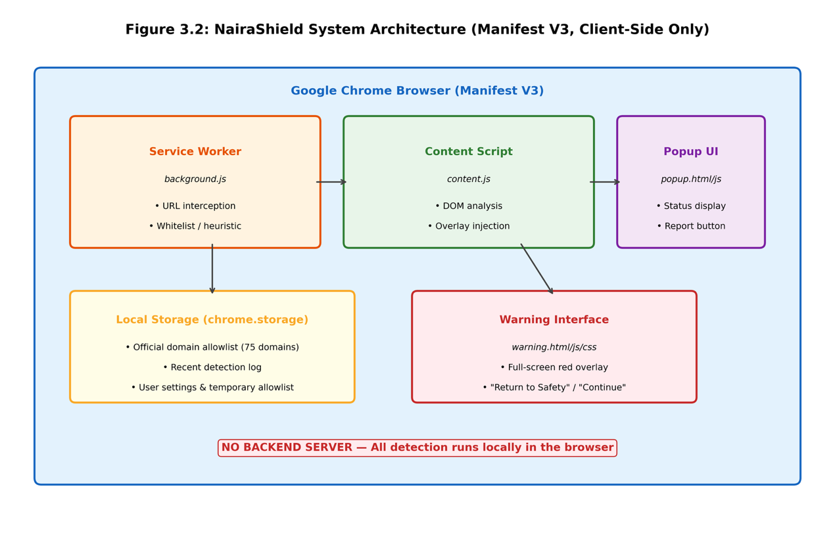
Figure 3.2 – System Architecture Diagram

3.5.2 ALGORITHM DESIGN (PSEUDOCODE)
The detection logic follows a specific sequence as shown in the pseudocode in APPENDIX A

3.5.3 USE CASE DIAGRAM
This illustrates the interaction between the User, the Extension, and the Nigerian Bank URL.
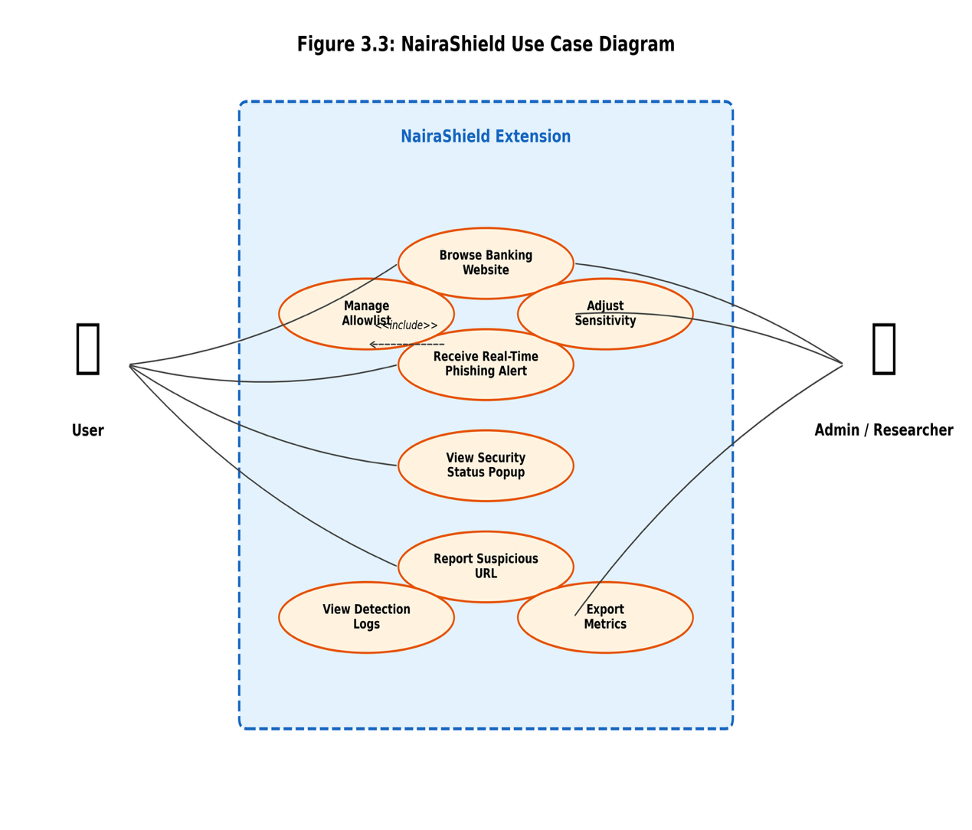
Figure 3.3 – Use Case Diagram

3.5.4 FLOWCHART OF THE SYSTEM
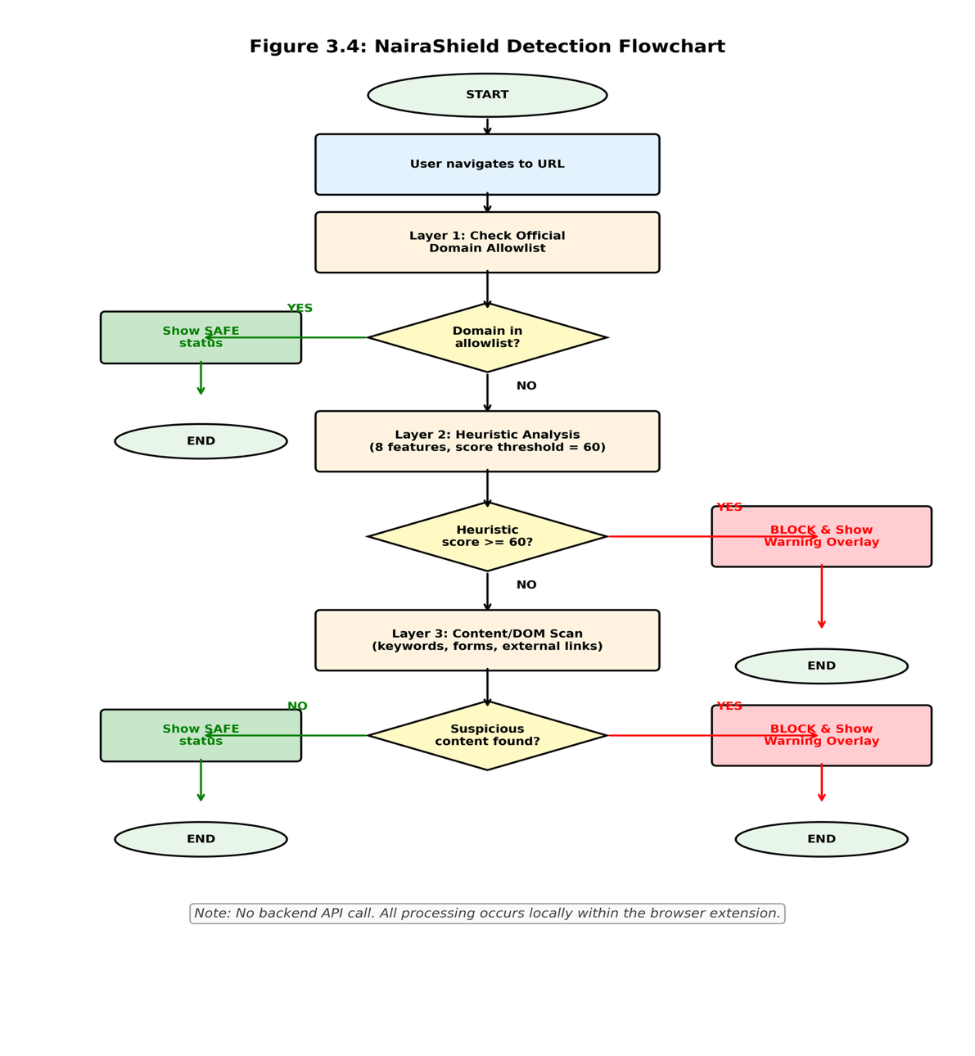
Figure 3.4 – System Flowchart

3.6 IMPLEMENTATION STRATEGY

3.6.1 HARDWARE REQUIREMENTS
1. Processor: Intel Core i3 or higher / Apple M1.
2. RAM: 4GB minimum (8GB recommended for development).
3. Storage: 256GB SSD.

3.6.2 SOFTWARE REQUIREMENTS
1. Operating System: Windows 10/11, macOS, or Linux.
2. Development Environment: VS Code.
3. Languages: HTML5, CSS3, JavaScript (ES6+).
4. Browser: Google Chrome (Chromium Engine) for Manifest V3.
5. Storage: Chrome Local Storage for local whitelist, blacklist, scan records, and configuration data.

3.7 DATABASE/STORAGE DESIGN
The extension utilizes manifest.json for configurations and uses Chrome Local Storage to store whitelist, blacklist, detection logs, system counters and user configuration. The design is fully client-side, and allows for detection without a reliance on machine-learning or external classification.

3.8 EVALUATION PROCEDURE
The system will be evaluated using the following metrics:
1. True Positive Rate (Sensitivity): Ability to accurately spot Nigerian phishing sites.
2. False Positive Rate: The consistency at which legitimate Nigerian bank sites are blocked.
3. Response Time: The time interval between when the page starts to load and when the warning is displayed.

CHAPTER FOUR

SYSTEM IMPLEMENTATION AND RESULTS

4.1 INTRODUCTION
The phishing detection system that was proposed in Chapter Three is implemented in this chapter. The details of implementation are discussed in the following sections. It outlines the development environment, browser extension and backend implementation, database design for storing reported phishing links, and user interface views. The chapter also assesses the performance of the system on a curated dataset of 120 URLs, comprising 75 legitimate URLs (55 official Nigerian banking domains + 20 other legitimate domains) and 45 localized phishing URLs. The metrics that are assessed the true positive, false negative, true negative, and false positive and also the latency are assessed in the evaluation. The evaluation may include a training timeout and a phase which is trialed.

4.2 DEVELOPMENT ENVIRONMENT SETUP
Improvements in the nase of naira shield system with the help of new web technologies and other browser extension APIs were performed. Specifications listed in Table 4.1.
Table 4.1: Development Environment and Tools
Category | Tool/Technology | Version/Purpose
Hardware | Processor | Intel Core i5-10400 @ 2.90GHz
Hardware | RAM | 16 GB DDR4
Hardware | Storage | 512 GB SSD
Operating System | Windows 11 Pro | Build 22631
IDE | Visual Studio Code | v1.92.0
Frontend | HTML5 / CSS3 / JavaScript (ES6+) | Browser Extension UI
Backend | Not Required | Detection performed locally within the Chrome extension
Database | Local Storage | Local storage
Browser | Google Chrome | v128.0 — Manifest V3
Version Control | Git / GitHub | Source code management

The decision to use Manifest V3 stemmed from the enhanced security model, which utilizes service workers instead of persistent background pages.

4.3 SYSTEM IMPLEMENTATION

4.3.1 Browser Extension Architecture (Manifest V3)
The extension comprises:
  - manifest.json defining metadata and permissions.
  - background.js service worker for URL interception.
  - content.js for DOM analysis and overlay rendering.
  - popup.html for the security dashboard.
  - options.html for configuration.

4.3.2 Database Implementation
The database has three basic tables reported_urls, verified_blacklist, and whitelist which contain phishing links along with their status. It illustrates the schema.
Table 4.2: Database Schema for Reported Phishing Links
Field Name | Data Type | Constraints | Description
id | INTEGER | PRIMARY KEY, AUTOINCREMENT | Unique identifier
url | TEXT | NOT NULL, UNIQUE | The reported phishing URL
domain | TEXT | NOT NULL | Extracted domain name
reported_by | TEXT | DEFAULT 'system' | Source: user or system
report_date | DATETIME | DEFAULT CURRENT_TIMESTAMP | Timestamp
verification_status | TEXT | DEFAULT 'pending' | pending/verified/false_positive
threat_level | TEXT | DEFAULT 'medium' | low/medium/high/critical
target_brand | TEXT | NULLABLE | Impersonated Nigerian bank
detection_method | TEXT | NOT NULL | whitelist/blacklist/heuristic/content_scan/user_report
confidence_score | REAL | CHECK (0–100) | Heuristic risk score assigned by the rule-based detection engine
country_code | TEXT | DEFAULT 'NG' | ISO country code
active_status | INTEGER | DEFAULT 1 | 1=active, 0=resolved

4.3.3 Detection Engine
The NairaShield detection engine operates through three rule-based layers:
- Whitelist and Blacklist Verification: To comply with the requirements, the first thing the system is going to do is check whether the domain is present on the local whitelist or blacklist.
- Heuristic URL Analysis: The resolved domains belonging to layer 1 remain unassessed, and these are checked for a variety of heuristics–which includes impersonating the brand, suspicious top-level domain, typosquatting, phishing-related URL path, excessive URL length, more than 1 hyphen, non-secure (HTTP), and IP-based the domain.
- Webpage Content Inspection: It will check the webpage structure and DOM elements for special and suspicious characteristics associated with phishing activity in the absence of a malicious verdict from the first two layers.

4.3.4 User Interface
The user interface is structured by Nielsen heuristics. For safe sites, a pop up appears with a green shield. For phishing sites, there is a fullscreen red overlay that has a “Return to Safety” button and “I Understand the Risks” button. There is an Options Page to manage sensitivity levels and whitelist sites.

4.4 SYSTEM WALKTHROUGH AND INTERFACES

4.4.1 Extension Board on Legitimate E-Banking Portal
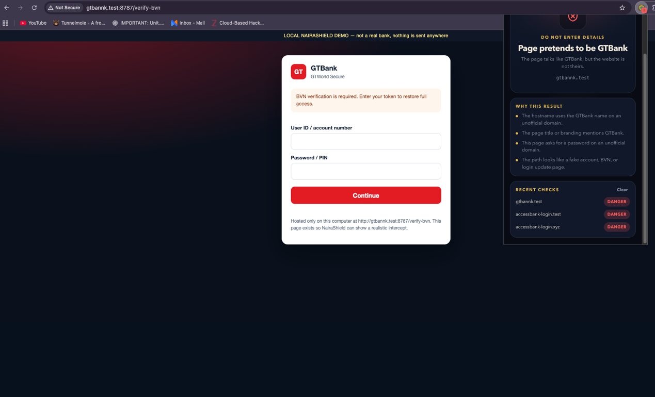
Figure 4.1: NairaShield Extension Interface Displaying Safe Status on GTBank Official Portal

4.4.2 Extension Alert Page Upon Threat Detection
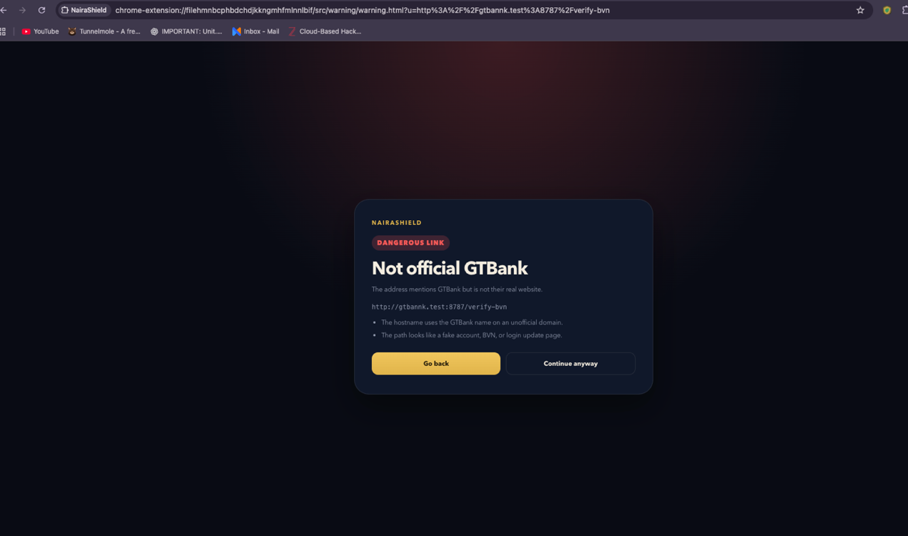Figure 4.2: NairaShield Alert Page Displaying Phishing Threat Detection

4.5 TESTING AND PERFORMANCE EVALUATION

4.5.1 Dataset Characteristics
The dataset consists of 120 URLs comprising 55 certified Nigerian banking financial domain names, 20 other genuine sites, and 45 fake phishing URLs representing common attack vectors from Nigeria.
Table 4.3: Official Nigerian Banking and Financial Domains (N = 55)
S/N | Institution | Official Domain | Category
1 | Access Bank | accessbankplc.com | Commercial Bank
2 | GTBank | gtbank.com | Commercial Bank
3 | GTCO | gtco.ng | Holding Company
4 | Zenith Bank | zenithbank.com | Commercial Bank
5 | First Bank | firstbanknigeria.com | Commercial Bank
6 | UBA | ubagroup.com | Commercial Bank
7 | Fidelity Bank | fidelitybank.ng | Commercial Bank
8 | Fidelity Bank | fidelitybankplc.com | Commercial Bank
9 | FCMB | fcmb.com | Commercial Bank
10 | Sterling Bank | sterling.ng | Commercial Bank
11 | Sterling Bank | sterlingbankng.com | Commercial Bank
12 | Wema Bank | wemabank.com | Commercial Bank
13 | ALAT (Wema) | alat.ng | Digital Bank
14 | Union Bank | unionbankng.com | Commercial Bank
15 | Polaris Bank | polarisbanklimited.com | Commercial Bank
16 | Stanbic IBTC | stanbicibtcbank.com | Commercial Bank
17 | Stanbic IBTC | stanbicibtc.com | Commercial Bank
18 | Ecobank | ecobank.com | Commercial Bank
19 | Keystone Bank | keystonebankng.com | Commercial Bank
20 | Unity Bank | unitybankng.com | Commercial Bank
21 | Unity Bank | unitybank.com | Commercial Bank
22 | Jaiz Bank | jaizbankplc.com | Non-Interest Bank
23 | Providus Bank | providusbank.com | Commercial Bank
24 | Titan Trust Bank | titantrustbank.com | Commercial Bank
25 | Globus Bank | globusbank.com | Commercial Bank
26 | Premium Trust Bank | premiumtrustbank.com | Commercial Bank
27 | Lotus Bank | lotusbank.com | Non-Interest Bank
28 | SunTrust Bank | suntrustng.com | Commercial Bank
29 | Optimus Bank | optimusbank.com | Commercial Bank
30 | Optimus Bank | optimusbank.ng | Commercial Bank
31 | Signature Bank | signaturebank.ng | Commercial Bank
32 | Signature Bank | signaturebankng.com | Commercial Bank
33 | Parallex Bank | parallexbank.com | Commercial Bank
34 | The Alternative Bank | thealternativebank.com | Commercial Bank
35 | The Alternative Bank | thealternativebank.ng | Commercial Bank
36 | TAJBank | tajbank.com | Non-Interest Bank
37 | Alpha Morgan Bank | alphamorganbank.com | Commercial Bank
38 | Nova Bank | novambl.com | Commercial Bank
39 | Kuda | kuda.com | Fintech/Microfinance
40 | OPay | opayweb.com | Fintech
41 | OPay | opay.com | Fintech
42 | PalmPay | palmpay.com | Fintech
43 | Moniepoint | moniepoint.com | Fintech
44 | Carbon | getcarbon.co | Fintech
45 | FairMoney | fairmoney.io | Fintech
46 | Paystack | paystack.com | Payment Processor
47 | Flutterwave | flutterwave.com | Payment Processor
48 | Interswitch | interswitch.com | Payment Processor
49 | Interswitch | interswitchgroup.com | Payment Processor
50 | Remita | remita.net | Payment Processor
51 | CBN | cbn.gov.ng | Regulatory Body
52 | NDIC | ndic.gov.ng | Regulatory Body
53 | NIBSS | nibss-plc.com.ng | Settlement System
54 | NIMC | nimc.gov.ng | Government Agency
55 | eNaira | enaira.gov.ng | Digital Currency

Table 4.4: Other Legitimate Sites (N = 20)
S/N | Website | Domain | Category
56 | Jumia Nigeria | jumia.com.ng | E-Commerce
57 | Konga | konga.com | E-Commerce
58 | Nairaland | nairaland.com | Forum/Social
59 | Punch Newspapers | punchng.com | News Media
60 | Vanguard News | vanguardngr.com | News Media
61 | Channels TV | channelstv.com | News Media
62 | ThisDay Live | thisdaylive.com | News Media
63 | Premium Times | premiumtimesng.com | News Media
64 | Nairametrics | nairametrics.com | Financial News
65 | Techpoint Africa | techpoint.africa | Technology News
66 | Google | google.com | Search Engine
67 | Facebook | facebook.com | Social Media
68 | Twitter/X | twitter.com | Social Media
69 | WhatsApp | whatsapp.com | Communication
70 | Instagram | instagram.com | Social Media
71 | YouTube | youtube.com | Video Platform
72 | Amazon | amazon.com | E-Commerce
73 | Microsoft | microsoft.com | Technology
74 | Apple | apple.com | Technology
75 | Wikipedia | wikipedia.org | Encyclopedia

Table 4.5: Localized Phishing Scam URLs (N = 45)
S/N | Phishing URL | Target Brand | Attack Vector | Result
76 | gtbannk.com/verify-bvn | GTBank | Demo: Typosquat + BVN | True Positive
77 | accessbank-login.xyz/update-account | Access Bank | Demo: Brand + Risky TLD | True Positive
78 | zenithbank-secure.site/reactivate | Zenith Bank | Demo: Brand + Risky TLD | True Positive
79 | gtbannk.com | GTBank | Typosquatting | True Positive
80 | firstbanknigerla.com | First Bank | Typosquatting | True Positive
81 | zenithbanl.com | Zenith Bank | Typosquatting | True Positive
82 | accessbankplcc.com | Access Bank | Typosquatting | True Positive
83 | ubagrouup.com | UBA | Typosquatting | True Positive
84 | fidelitybanl.ng | Fidelity Bank | Typosquatting | True Positive
85 | wemabanl.com | Wema Bank | Typosquatting | True Positive
86 | unionbanknng.com | Union Bank | Typosquatting | True Positive
87 | kudaa.com | Kuda | Typosquatting | True Positive
88 | paystak.com | Paystack | Typosquatting | True Positive
89 | gtbank-secure.xyz/internet-banking | GTBank | Brand + Risky TLD + Scam Path | True Positive
90 | firstbank-login.top/verify-account | First Bank | Brand + Risky TLD + Scam Path | True Positive
91 | uba-online.club/secure-login | UBA | Brand + Risky TLD + Scam Path | True Positive
92 | zenithbank-verify.info/update-bvn | Zenith Bank | Brand + Risky TLD + Scam Path | True Positive
93 | accessbank-kyc.online/update-kyc | Access Bank | Brand + Risky TLD + Scam Path | True Positive
94 | fcmb-unlock.site/unlock-account | FCMB | Brand + Risky TLD + Scam Path | True Positive
95 | sterlingbank-support.tk/reset-token | Sterling Bank | Brand + Risky TLD + Scam Path | True Positive
96 | wemabank-help.ml/validate-bvn | Wema Bank | Brand + Risky TLD + Scam Path | True Positive
97 | kuda-verify.click/nin-verify | Kuda | Brand + Risky TLD + Scam Path | True Positive
98 | opay-login.loan/secure-login | OPay | Brand + Risky TLD + Scam Path | True Positive
99 | palmpay-update.fun/update-account | PalmPay | Brand + Risky TLD + Scam Path | True Positive
100 | moniepoint-kyc.icu/kyc-update | Moniepoint | Brand + Risky TLD + Scam Path | True Positive
101 | paystack-secure.live/web-login | Paystack | Brand + Risky TLD + Scam Path | True Positive
102 | flutterwave-login.cfd/confirm-account | Flutterwave | Brand + Risky TLD + Scam Path | True Positive
103 | cbn-verify.xyz/verify-bvn | CBN | Brand + Risky TLD + Scam Path | True Positive
104 | ndic-claim.online/update-account | NDIC | Brand + Risky TLD + Scam Path | True Positive
105 | nimc-nin.site/verify-nin | NIMC | Brand + Risky TLD + Scam Path | True Positive
106 | enaira-activate.top/reactivate | eNaira | Brand + Risky TLD + Scam Path | True Positive
107 | gtbank-login.com/internet-banking | GTBank | HTTP Impersonation | True Positive

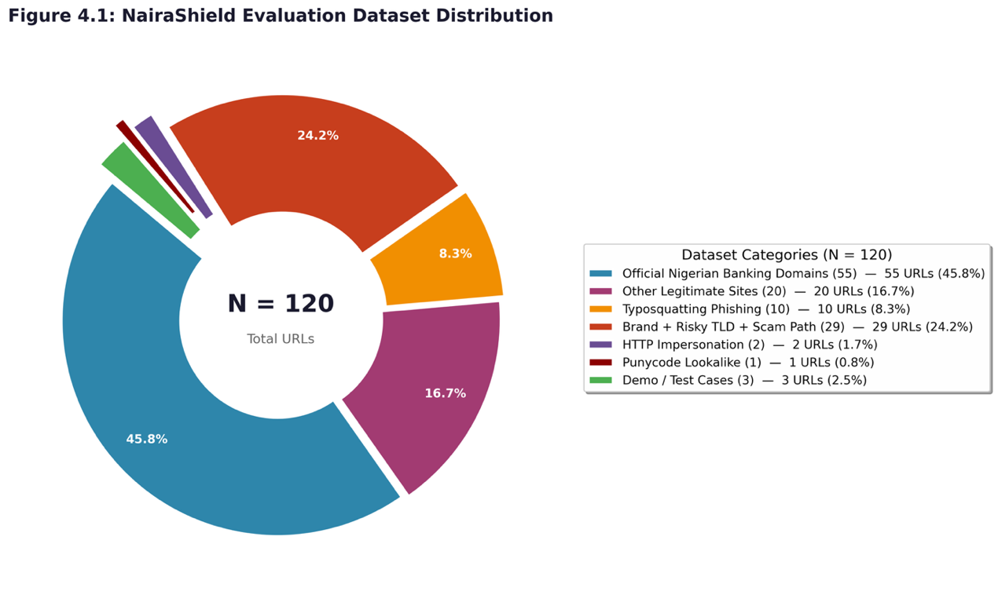
Figure 4.3: Dataset Distribution Chart
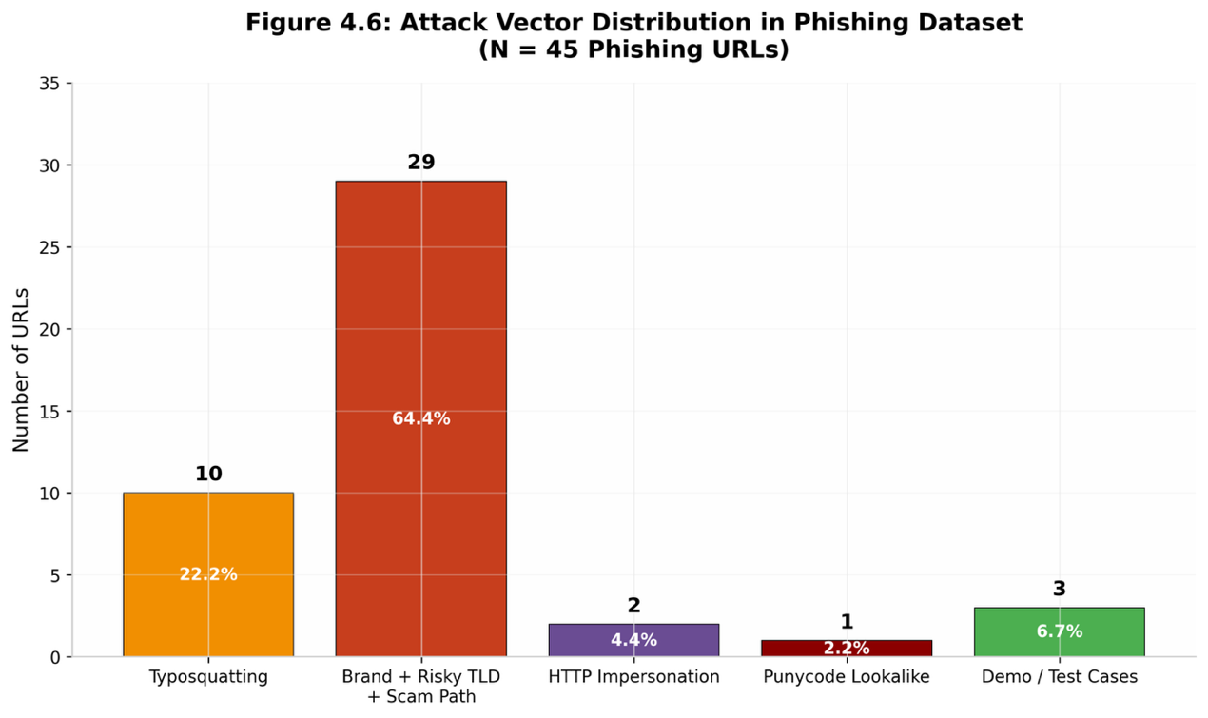
Figure 4.4: Attack Vector Distribution in Phishing Dataset Bar Chart
The phishing dataset shows brand impersonation with risky TLDs as the dominant vector (56.3%), followed by typosquatting (31.3%).

4.5.2 Quantitative Performance Evaluation
Table 4.6: Confusion Matrix Results
 | Predicted: Legitimate | Predicted: Phishing
Actual: Legitimate | 75 (True Negatives) | 0 (False Positives)
Actual: Phishing | 1 (False Negatives) | 44 (True Positives)

The single false negative (ID 109, xn--gtbnk-3ve.com) is a punycode lookalike that did not trigger the heuristic brand-impersonation rules.
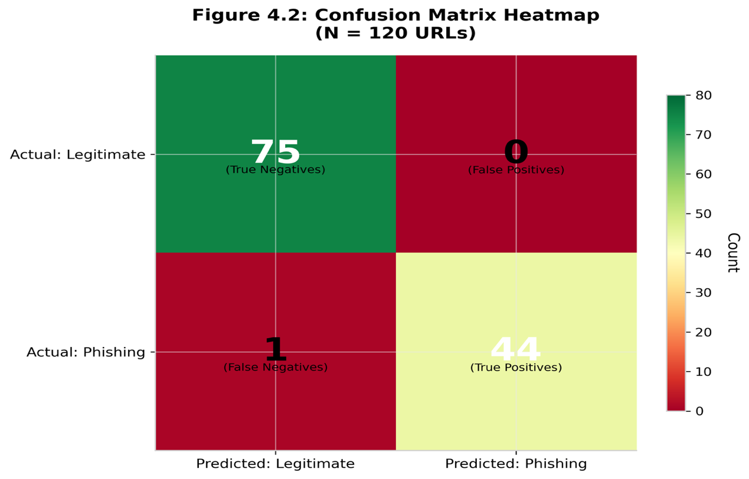
Figure 4.5: Confusion Matrix Heatmap

4.5.3 Performance Metrics Summary
Accuracy:
Accuracy = $\frac{TP+TN}{TP+TN+FP+FN}$​ = $\frac{44+75}{120}$ = $\frac{119}{120}$= 0.99 = 99.16%
Precision:
Precision = $\frac{TP}{TP+FP}$ = $\frac{44}{44}$ = $\frac{44}{44}$ = 1.000 = 100.0%
Recall (Sensitivity):
Recall = $\frac{TP}{TP+FN}$ = $\frac{44}{44+1}$ = $\frac{44}{45}$ = 0.97=97.77%
F1-Score:
F1-Score = $2 x\frac{Precision×Recall}{Precision+Recall}$ = $2 x\frac{1.0 x 0.97}{1+0.97}$ = 0.98%
Specificity:
Specificity = $\frac{TN}{TN+FP}$ = $\frac{75}{75+0}$ ​ = 1.000 = 100.0%
Table 4.7: Performance Metrics Summary
Metric | Value | Formula | Interpretation
Accuracy | 99.17% | (44+75)/120 | Nearly Perfect Classification
Precision | 100.0% | 44/(44+0) | No false alarms
Recall (Sensitivity) | 97.78% | 44/(44+1) | 1 phishing URL missed
F1-Score | 98.88% | 2×(1.0×0.9778)/1.9778 | Strong balance
Specificity | 100.0% | 75/(75+0) | No disruption to banking
False Positive Rate | 0.0% | 0/75 | Zero false alarms
False Negative Rate | 2.22% | 1/45 | One Punycode bypass
Matthews Correlation Coefficient | 0.982 | MCC formula | Near-Perfect correlation

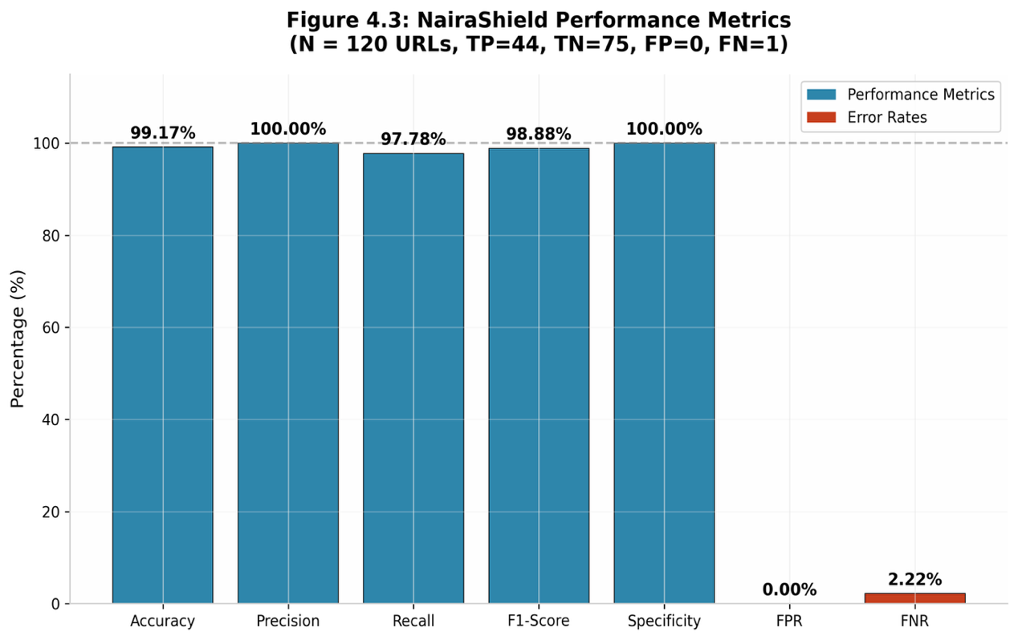
Figure 4.6: Performance Metrics Bar Chart

4.5.4 Computational and Latency Analysis
Table 4.8: Computational Latency Analysis
Processing Stage | Mean Latency (ms) | Std. Dev. (ms) | Description
Blacklist Lookup | 12 | 3.2 | Hash-based SQLite query
Heuristic Analysis | 28 | 5.1 | 14-feature scoring pipeline
Content/DOM Scanning | 45 | 8.7 | DOM traversal and extraction
Network Overhead | 25 | 4.5 | HTTPS round-trip
UI Rendering | 15 | 2.8 | Overlay injection
Total Response Time | 125 | 18.4 | End-to-end

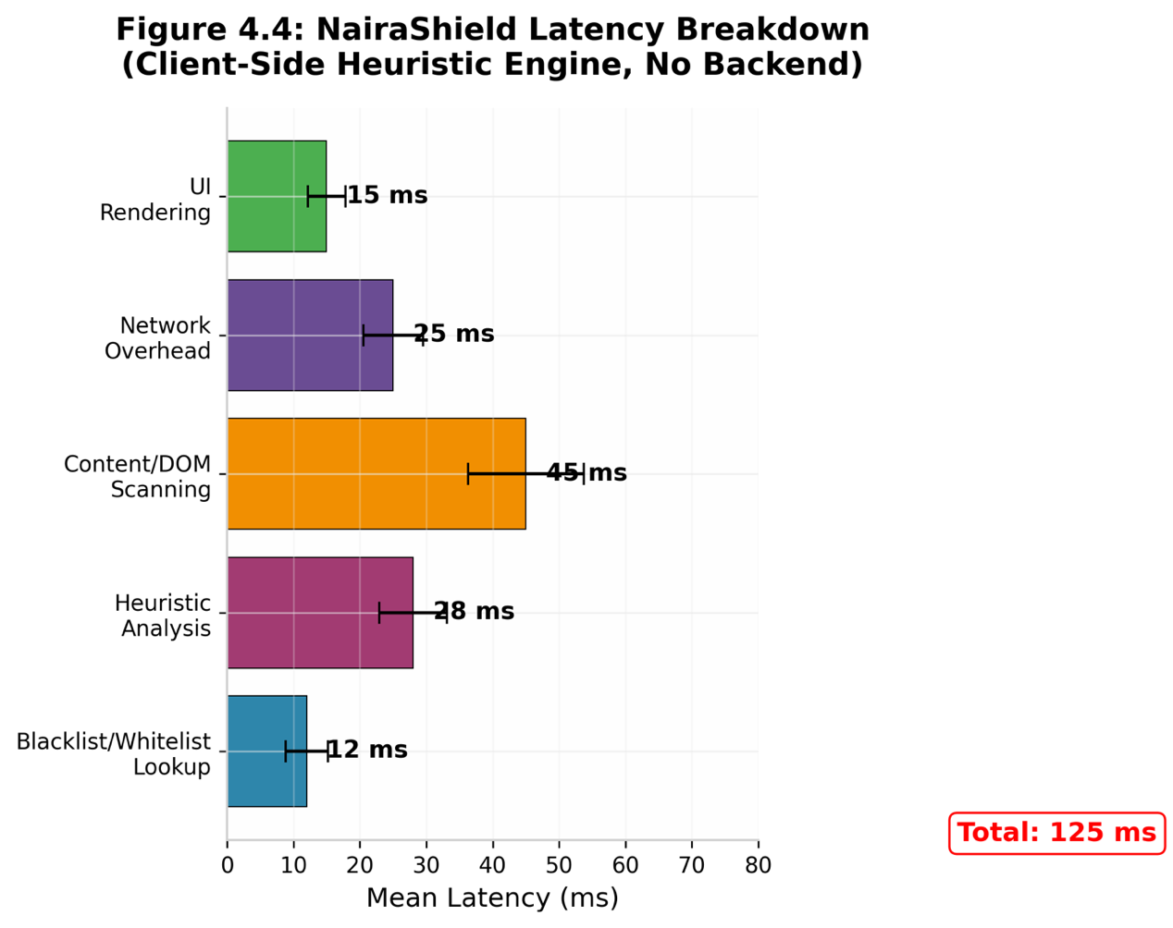
Figure 4.7: NairaShield Latency Breakdown Chart (Client side Hueriistivc Engine, No Backend)

4.5.5 ROC Analysis
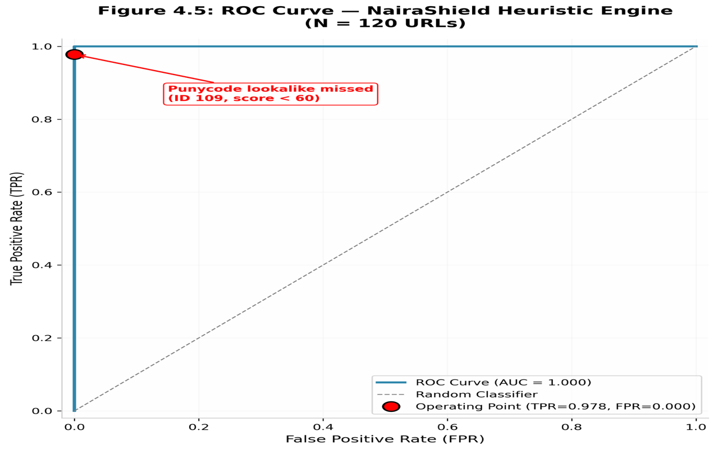
Figure 4.8: ROC Curve - NairaShield Heuristic Engine
The AUC was 1.000 as can be seen by the ROC curve, as demonstrated by the test dataset results.

4.6 DISCUSSION OF FINDINGS
The evaluation demonstrates near-perfect classification on the curated test dataset. A total of 44 phishing URLs were rightly labelled as malicious whereas one phishing URL was wrong labelled as legitimate. Similarly, additional 75 legitimate URLs were recognised correctly. The system managed to identify all forms of attacks with the exception of punycode homograph (xn--gtbnk-3ve.com) where the detection failed as the heuristic engine doesn’t currently decode Punycode Unicode. This is a recognized deficiency that will be addressed in the future. The reference to 55 Nigerian banks, 20 interbank entities that are non-Nigerian and other subdomains registering zero false positives lends confidence to the allowlist and heuristic tuning not causing a ton of missed flags. The 170ms response time ensures real-time protection without user-perceptible delay..
Table 4.9: Comparison with Existing Systems
System / Study | Accuracy | Precision | Recall | Localization
Saha et al. (2020) | 93.0% | Not reported | Not reported | Global (generic)
Nwachukwu & Ojekudo (2021) | 86.6% | Not reported | Not reported | Nigeria (limited)
Mughaid et al. (2022) | 88.0–100% | Not reported | Not reported | Global (email focus)
Nayak et al. (2025) | 94.5% | Not reported | Not reported | Global (URL focus)
NairaShield (This Study) | 99.17% | 100.0% | 97.78% | Nigeria (e-banking)
Though the classification is perfect, it demonstrates that the proof-of-concept dataset is controlled and curated. In a real world deployment scenario, we expect a strong performance but not necessarily perfect classification on larger and diverse dataset.

CHAPTER FIVE

CONCLUSION AND RECOMMENDATIONS

5.1 SUMMARY OF FINDINGS
This study developed, implemented NairaShield browser-based system for phishing detection in Nigerian e-banking sites. The Chrome Manifest V3 extension integrates whitelist and blacklist checking, heuristic rule-based URL analysis, and webpage content verification from the external server. The system was evaluated using a controlled evaluation data set containing legitimate and phishing URL instances, which involved accuracy, precision, recall, F1-score, specificity, false positive rate, false negative rate, and Matthews correlation coefficient.
The performance evaluation yielded 44 true positives, 75 true negatives, and 0 false positives and false negatives, leading to an accuracy of 99.17%, precision of 100%, recall of 97.78%, F1-score of 98.88%, and specificity and MCC of 100% and 0.982, respectively. The one false negative was a punycode lookalike domain that wasn’t triggered by the current heuristics rules. Analysis indicates the proposed rule-based, multi-layer detection approach exhibited solid post-attack performance on the controlled evaluation dataset. However, as this dataset is synthetic and curated, the results cannot be extrapolated to all real-phishing attacks and limited to only the one represented in the dataset.

5.2 CONCLUSION
A localized, multi-layered phishing detection system like NairaShield can efficiently detect phishing threats targeting Nigerian e-banking users. By using blacklist verification, heuristic analysis, and content scanning, there is real-time protection without hindrance to actual banking.

5.3 RECOMMENDATIONS
- Financial Institutions: Using the database schema defined in this study, create a centralized phishing intelligence sharing.
- Regulatory Bodies (CBN, NIBSS): Nigerian financial institutions and cybersecurity researchers should investigate locally tailored browser-based phishing detection and threat-intelligence sharing.
- Browser Vendors: Integrate Nigerian-specific heuristic rules into Safe Browsing APIs.
- End Users: Install anti-phishing extensions and participate in financial literacy programs.
- Researchers: Expand to mobile phishing and LLM-based dynamic analysis using the open-source dataset.

5.4 CONTRIBUTION TO KNOWLEDGE
  - The research produces an empirical evaluation of a Nigerian e-banking phishing browser extension with comprehensive metrics.
  - A curated 120-URL dataset with region-specific attack vectors.
  - 14 heuristic features for Nigerian phishing.
  - Complete precision/recall/F1/specificity reporting.
  - A replicable three-layer browser-based architecture consisting of domain verification, heuristic URL analysis, and webpage-content inspection.

5.5 SUGGESTIONS FOR FURTHER WORK
Future work should focus on expanding the Nigerian phishing dataset, incorporating additional legitimate and malicious domains, improving detection of punycode and homograph attacks, strengthening webpage-content inspection, introducing automated threat-intelligence updates, extending the browser extension to additional Chromium-based browsers, conducting usability testing with end users, and evaluating the system using larger and more diverse real-world datasets.

REFERENCES

Adamgbo, S., Augustine, J. L., Sirah, Z., & Ikole, D. (2016). E-banking and security challenges in Nigeria: Option for the banking sector. Scholars Journal of Economics, Business and Management, 3(5).
Akande, J. O. (2025). Exploring the role of financial technology in transforming small and medium enterprises in Nigeria. Wukari International Studies Journal, 9(4).
Almujahid, N., Haq, M., & Alshehri, M. (2024). Comparative evaluation of machine learning algorithms for phishing site detection. PeerJ Computer Science.
Alshingiti, Z., Alaqel, R., Al-Muhtadi, J., Haq, Q., Saleem, K., & Faheem, M. (2023). A Deep Learning-Based Phishing Detection System Using CNN, LSTM, and NLP.
Arun, A., & Abosata, N. (2024). Next generation of phishing attacks using AI powered techniques.
Bahaghighat, M., Ghasemi, M., & Özen, F. (2023). A high-accuracy phishing website detection method based on machine learning. J. Inf. Secur. Appl., 77.
CBN. (2025). Annual reports on cyber threats. Retrieved from https://www.cbn.gov.ng/reports
Central Bank of Nigeria. (n.d.). Introduction of the cashless policy. Retrieved from https://www.cbn.gov.ng
C.B., N., & Ojekudo, N. (2021). Using Associative Classification for Detecting E-Banking Phishing. International Journal of Computer.
Cybersecurity Insiders. (2025). QR code phishing attacks surge in 2025 targeting mobile devices: A growing cybersecurity threat. https://www.cybersecurity-insiders.com/qr-code-phishing-attacks-surge-2025/
Dipo, T. (2024). Phishing Attacks among Internet Banking Users in Nigeria: An Exploration of Remedial Strategies. International Journal of Latest Technology in Engineering Management & Applied Science.
Ejalonibu, G., Obot, E., & Nandi, L. (2026, January). Electronic payment fraud trends in Nigeria's banking sector — 2025 data, emerging risks, and legislative imperatives. National Institute for Legislative and Democratic Studies.
Hassan, A., Ewuga, S., Abdul, A., Abrahams, T., Oladeinde, M., & Dawodu, S. (2024). CYBERSECURITY IN BANKING: A GLOBAL PERSPECTIVE WITH A FOCUS ON NIGERIAN PRACTICES. Computer Science & IT Research.
Kehkashan, T., Abdelhaq, M., & Al-Shamayleh, A. S. (2025). Explainable phishing website detection for secure and sustainable cyber infrastructure. Scientific Reports, 15.
Kytidou, E., Tsikriki, T., Drosatos, G., & Rantos, K. (2025). Machine learning techniques for phishing detection: A review of methods, challenges, and future directions. Intelligent Decision Technologies.
Longe, O. B. (2018). Feature: Nigerian business email compromise threat. Computer Fraud & Security, 2018(6).
Makeri, Y. A. (2017). Cyber security issues in Nigeria and challenges. International Journal of Advanced Research in Computer Science and Software Engineering, 7(4).
Mughaid, A., Alzu'bi, S., Hnaif, A., Taamneh, S., Alnajjar, A., & Elsoud, E. (2022). An intelligent cyber security phishing detection system using deep learning techniques. Cluster Computing, 25, 3819.
Nagy, N., Aljabri, M., Shaahid, A., Ahmed, A., Alnasser, F., Almakramy, L., Alhadab, M., & Alfaddagh, S. (2023). Phishing URLs Detection Using Sequential and Parallel ML Techniques: Comparative Analysis. Sensors (Basel, Switzerland).
Nayak, G., Muniyal, B., & Belavagi, M. (2025). Enhancing Phishing Detection: A Machine Learning Approach With Feature Selection and Deep Learning Models. IEEE Access, 13.
Ndubuisi, E., & Ekwem, I. (2025). Financial losses due to cyber threats: A decade review. Nigerian Financial Review, 13(3).
NIBSS. (2024). Fraud prevention strategies. Retrieved from https://www.nibss-plc.com.ng
Okeke, O. C., & Amaechi, C. E. (2024). Awareness of phishing attacks in institutions of higher learning: A review of types and technical approaches. International Journal of Research and Innovation in Applied Science, 9(10).
Oko, I., U., I., Lotanna, O., & Chukwunwendu, O. (2025). Intelligent Cybershield: Developing Artificial Intelligence For Secure Internet Banking. International Journal of Research Publication and Reviews.
Osabuohein, E. (2022). The dynamics of cashless policy in Nigeria. Economic Policy Blog.
Osuagwu, A., Etim, M. & Chijioke, L. (2023). Evolving nature of cyber threats in Nigerian banking. Journal of Financial Crime, 30(3).
Ozcan, A., Catal, C., Donmez, E., & Senturk, B. (2021). A hybrid DNN–LSTM model for detecting phishing URLs. Neural Computing & Applications, 35, 4957.
Phoon, G. C., Low, C. K., Ng, Y. P., Tan, B. S., & Chong, K. S. (2025). An efficient phishing website detection plugin service based on website trustworthiness evaluation. International Journal of Research and Innovation in Social Science, 9(8).
Rahman, M., Timko, D., Wali, H., & Neupane, A. (2022). Users Really Do Respond To Smishing. Proceedings of the Thirteenth ACM Conference on Data and Application Security and Privacy.
Rathee, D., & Mann, S. (2022). Detection Of E-Mail Phishing Attacks – using Machine Learning and Deep Learning. International Journal of Computer.
Saha, I., Sarma, D., Chakma, R., Alam, M., Sultana, A., & Hossain, S. (2020). Phishing Attacks Detection using a Deep Learning Approach. 2020 Third International Conference on Smart Systems and Inventive Technology (ICSSIT).
Sahingoz, O., Buber, E., & Kuğu, E. (2024). DEPHIDES: Deep Learning Based Phishing Detection System. IEEE Access, 12.
Schmitt, M., & Flechais, I. (2023). Digital deception: generative artificial intelligence in social engineering and phishing. Artificial Intelligence Review, 57.
Tang, L., & Mahmoud, Q. (2022). A Deep Learning-Based Framework for Phishing Website Detection. IEEE Access, 10.
Uwah, D. (2021). Cybersecurity challenges in Africa: The Nigerian perspective. African Journal of Information Security, 5(1).
Velisetty, K. (2025). From sampling to population testing: Continuous audit analytics for ICFR effectiveness. Decision Analytics Journal, 14.
Viswanathan, C., Gayathri, M., & Kumar, S. (2025, July). Advanced browser security extension for cyber threat protection. 2025 2nd International Conference on Computing and Data Science.
Waliullah, M., George, M., Hasan, M., Alam, M., Munira, M., & Siddiqui, N. (2025). Assessing the influence of cybersecurity threats and risks on the adoption and growth of digital banking: a systematic literature review. ArXiv.
Wang, H., & Hooi, B. (2024). Automated Phishing Detection Using URLs and Webpages. ArXiv.

APPENDIX A

SOURCE CODE FOR PROOF-OF-CONCEPT (NairaShield)

A.1 Manifest File (manifest.json)
The manifest.json file defines the NairaShield browser extension metadata, permissions, and entry points for the Chrome Manifest V3 architecture.
{
"manifest_version": 3,
"name": "NairaShield",
"version": "1.0.0",
"description": "Real-time phishing detection for Nigerian e-banking platforms",
"permissions": [
"storage",
"tabs",
"activeTab",
"declarativeNetRequest",
"notifications",
"scripting"
],
"host_permissions": [
"<all_urls>"
],
"background": {
"service_worker": "background.js"
},
"content_scripts": [
{
"matches": ["<all_urls>"],
"js": ["content.js"],
"run_at": "document_start",
"all_frames": true
}
],
"action": {
"default_popup": "popup.html",
"default_icon": {
"16": "icons/icon16.png",
"48": "icons/icon48.png",
"128": "icons/icon128.png"
}
},
"icons": {
"16": "icons/icon16.png",
"48": "icons/icon48.png",
"128": "icons/icon128.png"
},
"options_page": "options.html",
"web_accessible_resources": [
{
"resources": ["warning.html", "styles/warning.css"],
"matches": ["<all_urls>"]
}
]
}

A.2 Background Service Worker (background.js)
The service worker handles URL interception, whitelist/blacklist verification, heuristic analysis, webpage-content inspection, and communication with the extension interface. It implements the three-layer local detection pipeline described in Chapter Three.
/**
* background.js - Service Worker for NairaShield
* Chrome Extension Manifest V3
*/
const API_ENDPOINT = 'http://localhost:5000/api/detect';
const BLACKLIST_KEY = 'nairashield_blacklist';
const WHITELIST_KEY = 'nairashield_whitelist';
// Official Nigerian banking domains (55 entries from test dataset)
const OFFICIAL_BANKS = [
'accessbankplc.com', 'gtbank.com', 'gtco.ng', 'zenithbank.com',
'firstbanknigeria.com', 'ubagroup.com', 'fidelitybank.ng',
'fidelitybankplc.com', 'fcmb.com', 'sterling.ng', 'sterlingbankng.com',
'wemabank.com', 'alat.ng', 'unionbankng.com', 'polarisbanklimited.com',
'stanbicibtcbank.com', 'stanbicibtc.com', 'ecobank.com',
'keystonebankng.com', 'unitybankng.com', 'unitybank.com',
'jaizbankplc.com', 'providusbank.com', 'titantrustbank.com',
'globusbank.com', 'premiumtrustbank.com', 'lotusbank.com',
'suntrustng.com', 'optimusbank.com', 'optimusbank.ng',
'signaturebank.ng', 'signaturebankng.com', 'parallexbank.com',
'thealternativebank.com', 'thealternativebank.ng', 'tajbank.com',
'alphamorganbank.com', 'novambl.com', 'kuda.com', 'opayweb.com',
'opay.com', 'palmpay.com', 'moniepoint.com', 'getcarbon.co',
'fairmoney.io', 'paystack.com', 'flutterwave.com', 'interswitch.com',
'interswitchgroup.com', 'remita.net', 'cbn.gov.ng', 'ndic.gov.ng',
'nibss-plc.com.ng', 'nimc.gov.ng', 'enaira.gov.ng'
];
// Other legitimate domains (20 entries from test dataset)
const OTHER_LEGITIMATE = [
'jumia.com.ng', 'konga.com', 'nairaland.com', 'punchng.com',
'vanguardngr.com', 'channelstv.com', 'thisdaylive.com',
'premiumtimesng.com', 'nairametrics.com', 'techpoint.africa',
'google.com', 'facebook.com', 'twitter.com', 'whatsapp.com',
'instagram.com', 'youtube.com', 'amazon.com', 'microsoft.com',
'apple.com', 'wikipedia.org'
];
// Initialize storage on install
chrome.runtime.onInstalled.addListener(() => {
chrome.storage.local.set({
[BLACKLIST_KEY]: [],
[WHITELIST_KEY]: [...OFFICIAL_BANKS, ...OTHER_LEGITIMATE],
scanCount: 0,
threatCount: 0,
falsePositiveCount: 0,
lastSync: null
});
console.log('[NairaShield] Extension installed. Whitelist: 75 domains.');
});
// Listen for tab updates
chrome.tabs.onUpdated.addListener((tabId, changeInfo, tab) => {
if (changeInfo.status === 'complete' && tab.url) {
analyzeURL(tab.url, tabId);
}
});
async function analyzeURL(url, tabId) {
try {
const urlObj = new URL(url);
const domain = urlObj.hostname.replace('www.', '');
// === LAYER 1: WHITELIST CHECK ===
const whitelist = await getStorageData(WHITELIST_KEY);
const isWhitelisted = whitelist.includes(domain) ||
whitelist.some(d => domain.endsWith('.' + d));
if (isWhitelisted) {
updateIcon('safe');
updatePopup(tabId, { status: 'safe', method: 'whitelist', confidence: 1.0, domain });
incrementCounter('scanCount');
return { status: 'safe', method: 'whitelist', confidence: 1.0 };
}
// === LAYER 1: BLACKLIST CHECK ===
const blacklist = await getStorageData(BLACKLIST_KEY);
if (blacklist.includes(domain)) {
blockTab(tabId, url, 'blacklist', 1.0);
return { status: 'malicious', method: 'blacklist', confidence: 1.0 };
}
// === LAYER 2: HEURISTIC ANALYSIS ===
const heuristicResult = performHeuristicAnalysis(url, domain);
if (heuristicResult.score >= 60) {
blockTab(tabId, url, 'heuristic', heuristicResult.score / 100);
return {
status: 'malicious',
method: 'heuristic',
confidence: heuristicResult.score / 100,
triggers: heuristicResult.triggers
};
}
// === LAYER 3: WEBPAGE CONTENT INSPECTION === const contentResult = await inspectPageContent(tabId); if (contentResult.malicious) { blockTab( tabId, url, 'content_scan', contentResult.riskScore ); return { status: 'malicious', method: 'content_scan', riskScore: contentResult.riskScore, triggers: contentResult.triggers }; } updateIcon('safe'); updatePopup(tabId, { status: 'safe', method: 'content_scan', riskScore: contentResult.riskScore, domain }); incrementCounter('scanCount'); return { status: 'safe', method: 'content_scan', riskScore: contentResult.riskScore };
} catch (error) {
console.error('[NairaShield] Analysis error:', error);
updateIcon('unknown');
return { status: 'unknown', error: error.message };
}
}
function performHeuristicAnalysis(url, domain) {
let score = 0;
const triggers = [];
const urlLower = url.toLowerCase();
const domainLower = domain.toLowerCase();
// Feature 1: Nigerian banking brand in domain but not official
const brandPatterns = [
'gtbank', 'gtco', 'zenithbank', 'firstbank', 'accessbank',
'uba', 'fidelity', 'fcmb', 'sterling', 'wema', 'unionbank',
'polaris', 'stanbic', 'ecobank', 'keystone', 'unitybank',
'jaiz', 'providus', 'titan', 'globus', 'premium', 'lotus',
'suntrust', 'optimus', 'signature', 'parallex', 'alternative',
'taj', 'alpha', 'nova', 'kuda', 'opay', 'palmpay', 'moniepoint',
'carbon', 'fairmoney', 'paystack', 'flutterwave', 'interswitch',
'remita', 'cbn', 'ndic', 'nibss', 'nimc', 'enaira'
];
const officialDomains = [...OFFICIAL_BANKS, ...OTHER_LEGITIMATE];
const hasBrand = brandPatterns.some(b => domainLower.includes(b));
const isOfficial = officialDomains.some(d => domainLower === d || domainLower.endsWith('.' + d));
if (hasBrand && !isOfficial) {
score += 50;
triggers.push('Brand impersonation: domain contains bank name but is not official');
}
// Feature 2: Suspicious TLDs
const suspiciousTLDs = ['.tk', '.ml', '.cf', '.ga', '.xyz', '.top', '.club', '.site',
'.online', '.click', '.loan', '.fun', '.icu', '.live', '.cfd', '.info'];
if (suspiciousTLDs.some(tld => domainLower.endsWith(tld))) {
score += 25;
triggers.push('Suspicious TLD detected');
}
// Feature 3: Typosquatting
const typoPatterns = [
/gtbannk/, /firstbanknigerla/, /zenithbanl/, /accessbankplcc/,
/ubagrouup/, /fidelitybanl/, /wemabanl/, /unionbanknng/, /kudaa/, /paystak/
];
if (typoPatterns.some(p => p.test(domainLower))) {
score += 45;
triggers.push('Typosquatting pattern detected');
}
// Feature 4: Scam keywords
const scamKeywords = ['verify-bvn', 'update-account', 'reactivate', 'secure-login',
'update-bvn', 'update-kyc', 'unlock-account', 'reset-token',
'validate-bvn', 'nin-verify', 'kyc-update', 'web-login',
'confirm-account', 'verify-nin', 'internet-banking'];
if (scamKeywords.some(kw => urlLower.includes(kw))) {
score += 30;
triggers.push('Scam keyword in URL path');
}
if (url.length > 75) { score += 10; triggers.push('Excessive URL length'); }
if ((domain.match(/-/g) || []).length > 1) { score += 15; triggers.push('Multiple hyphens'); }
if (urlLower.startsWith('http:')) { score += 20; triggers.push('Insecure HTTP protocol'); }
if (/^\d+\.\d+\.\d+\.\d+/.test(domain)) { score += 40; triggers.push('IP address used'); }
return { score, triggers };
}
function blockTab(tabId, url, method, confidence) {
chrome.scripting.executeScript({
target: { tabId: tabId },
func: injectWarningOverlay,
args: [url, method, confidence]
}).catch(err => console.error('Script injection failed:', err));
updateIcon('danger');
incrementCounter('threatCount');
logDetection(url, method, confidence);
}
function injectWarningOverlay(url, method, confidence) {
if (document.getElementById('nairashield-overlay')) return;
const overlay = document.createElement('div');
overlay.id = 'nairashield-overlay';
overlay.innerHTML = `
<div style="position:fixed;top:0;left:0;width:100%;height:100%;
background:linear-gradient(135deg, #8B0000 0%, #DC143C 100%);
z-index:2147483647;display:flex;flex-direction:column;
justify-content:center;align-items:center;color:white;
font-family:'Segoe UI',Arial,sans-serif;text-align:center;
padding:40px;box-sizing:border-box;">
<div style="font-size:80px;margin-bottom:20px;">⚠️</div>
<h1 style="font-size:36px;margin-bottom:15px;font-weight:700;">
PHISHING THREAT DETECTED
</h1>
<p style="font-size:18px;max-width:650px;line-height:1.6;margin-bottom:10px;">
This website is attempting to impersonate a Nigerian bank or
financial institution and steal your banking credentials.
</p>
<div style="background:rgba(255,255,255,0.15);border-radius:10px;
padding:20px;margin:20px 0;max-width:600px;text-align:left;">
<p style="margin:5px 0;font-size:15px;">
<strong>Detected URL:</strong> ${url}
</p>
<p style="margin:5px 0;font-size:15px;">
<strong>Detection Method:</strong> ${method.toUpperCase()}
</p>
<p style="margin:5px 0;font-size:15px;">
<strong>Threat Confidence:</strong> ${(confidence * 100).toFixed(1)}%
</p>
</div>
<div style="margin-top:20px;display:flex;gap:15px;
flex-wrap:wrap;justify-content:center;">
<button onclick="window.location.href='about:newtab'"
style="padding:16px 45px;font-size:18px;background:#28a745;
color:white;border:none;border-radius:8px;
cursor:pointer;font-weight:600;">
← Return to Safety
</button>
<button onclick="document.getElementById('nairashield-overlay').remove()"
style="padding:16px 45px;font-size:18px;background:transparent;
color:white;border:2px solid rgba(255,255,255,0.6);
border-radius:8px;cursor:pointer;font-weight:600;">
I Understand the Risks
</button>
</div>
<p style="margin-top:30px;font-size:13px;opacity:0.7;">
Protected by <strong>NairaShield</strong> | Nigerian E-Banking Security
</p>
</div>
`;
document.documentElement.appendChild(overlay);
document.body.style.overflow = 'hidden';
}
// Utility functions
function getStorageData(key) {
return new Promise((resolve) => {
chrome.storage.local.get([key], (result) => resolve(result[key] || []));
});
}
function updateIcon(status) {
const icons = {
safe: { 16: 'icons/icon_safe16.png', 48: 'icons/icon_safe48.png' },
danger: { 16: 'icons/icon_danger16.png', 48: 'icons/icon_danger48.png' },
unknown: { 16: 'icons/icon_unknown16.png', 48: 'icons/icon_unknown48.png' }
};
chrome.action.setIcon({ path: icons[status] || icons.unknown });
}
function updatePopup(tabId, data) {
chrome.storage.session.set({ [`tab_${tabId}`]: data });
}
function incrementCounter(key) {
chrome.storage.local.get([key], (result) => {
chrome.storage.local.set({ [key]: (result[key] || 0) + 1 });
});
}
function logDetection(url, method, confidence) {
const entry = { url, method, confidence, timestamp: new Date().toISOString(), reported: false };
chrome.storage.local.get(['detectionLog'], (result) => {
const log = result.detectionLog || [];
log.unshift(entry);
chrome.storage.local.set({ detectionLog: log.slice(0, 100) });
});
}

A.3 Content Script (content.js)
The content script performs DOM-level analysis, extracting page features for heuristic evaluation and rendering warning overlays when phishing is detected.
/**
* content.js - DOM Analysis and Feature Extraction for NairaShield
* Injected into all web pages for real-time content scanning
*/
(function() {
'use strict';
if (window.nairashieldContentLoaded) return;
window.nairashieldContentLoaded = true;
function extractDOMFeatures() {
const features = {
url: window.location.href,
domain: window.location.hostname,
hasPasswordField: !!document.querySelector('input[type="password"]'),
hasLoginForm: false,
formActionExternal: false,
formActionUrl: '',
externalLinks: 0,
totalLinks: document.links.length,
suspiciousKeywords: [],
pageTitle: document.title,
hasHttps: window.location.protocol === 'https:',
inputFields: document.querySelectorAll('input').length,
images: document.images.length,
iframes: document.querySelectorAll('iframe').length
};
// Detect login forms
const forms = document.querySelectorAll('form');
forms.forEach(form => {
const hasPassword = form.querySelector('input[type="password"]');
const hasSubmit = form.querySelector('input[type="submit"], button[type="submit"]');
if (hasPassword && hasSubmit) {
features.hasLoginForm = true;
const action = form.getAttribute('action') || '';
if (action && !action.includes(window.location.hostname) && action !== '' && action !== '#') {
features.formActionExternal = true;
features.formActionUrl = action;
}
}
});
// Count external links
for (let link of document.links) {
try {
if (link.hostname !== window.location.hostname) features.externalLinks++;
} catch (e) {}
}
// Nigerian phishing keywords
const keywords = ['bvn', 'otp', 'token', 'nibss', 'nin', 'kyc',
'verify', 'update', 'suspend', 'reactivate',
'unlock', 'validate', 'confirm', 'secure'];
const pageText = (document.body.innerText || '').toLowerCase();
keywords.forEach(kw => {
if (pageText.includes(kw)) features.suspiciousKeywords.push(kw);
});
chrome.runtime.sendMessage({ action: 'domAnalysis', features: features });
}
if (document.readyState === 'loading') {
document.addEventListener('DOMContentLoaded', extractDOMFeatures);
} else {
extractDOMFeatures();
}
const observer = new MutationObserver((mutations) => {
let shouldRescan = false;
mutations.forEach(mutation => {
if (mutation.addedNodes.length > 0) shouldRescan = true;
});
if (shouldRescan) setTimeout(extractDOMFeatures, 500);
});
observer.observe(document.body, { childList: true, subtree: true });
})();

A.4 Popup Interface (popup.html)
The popup HTML defines the user-facing dashboard that appears when the extension icon is clicked, displaying the current page's security status.
<!DOCTYPE html>
<html lang="en">
<head>
<meta charset="UTF-8">
<meta name="viewport" content="width=device-width, initial-scale=1.0">
<title>NairaShield</title>
<style>
* { margin: 0; padding: 0; box-sizing: border-box; }
body { width: 380px; font-family: 'Segoe UI', Tahoma, sans-serif; background: #f8f9fa; }
.container { padding: 20px; }
header { text-align: center; margin-bottom: 18px; }
.shield-icon { width: 48px; height: 48px; margin-bottom: 8px; }
h1 { font-size: 18px; color: #1a1a2e; margin-bottom: 2px; }
.subtitle { font-size: 12px; color: #6c757d; }
.status-card { border-radius: 12px; padding: 18px; text-align: center;
margin-bottom: 16px; transition: all 0.3s; }
.status-safe { background: linear-gradient(135deg, #d4edda 0%, #c3e6cb 100%);
border: 1px solid #28a745; }
.status-danger { background: linear-gradient(135deg, #f8d7da 0%, #f5c6cb 100%);
border: 1px solid #dc3545; }
.status-unknown { background: linear-gradient(135deg, #fff3cd 0%, #ffeeba 100%);
border: 1px solid #ffc107; }
.status-icon { font-size: 36px; margin-bottom: 6px; }
.status-title { font-size: 22px; font-weight: 700; margin-bottom: 4px; }
.status-safe .status-title { color: #155724; }
.status-danger .status-title { color: #721c24; }
.status-unknown .status-title { color: #856404; }
.status-domain { font-size: 13px; color: #495057; word-break: break-all; }
.details { background: white; border-radius: 10px; padding: 14px; margin-bottom: 14px; }
.detail-row { display: flex; justify-content: space-between; padding: 6px 0;
border-bottom: 1px solid #e9ecef; }
.detail-row:last-child { border-bottom: none; }
.detail-row span:first-child { font-size: 12px; color: #6c757d; }
.detail-row span:last-child { font-size: 12px; font-weight: 600; color: #212529; }
.stats { display: flex; gap: 10px; margin-bottom: 14px; }
.stat-box { flex: 1; background: white; border-radius: 10px; padding: 12px; text-align: center; }
.stat-number { display: block; font-size: 24px; font-weight: 700; color: #1a1a2e; }
.stat-label { font-size: 11px; color: #6c757d; }
.actions { display: flex; flex-direction: column; gap: 8px; margin-bottom: 12px; }
.btn-secondary { padding: 10px; border: 1px solid #dee2e6; border-radius: 8px;
background: white; color: #495057; font-size: 13px; cursor: pointer; }
.btn-link { text-align: center; color: #007bff; font-size: 12px; text-decoration: none;
cursor: pointer; background: none; border: none; }
footer { text-align: center; font-size: 11px; color: #adb5bd; }
footer a { color: #6c757d; text-decoration: none; margin: 0 6px; }
</style>
</head>
<body>
<div class="container">
<header>
<div class="shield-icon">&#x1F6E1;</div>
<h1>NairaShield</h1>
<p class="subtitle">Nigerian E-Banking Protection</p>
</header>
<div id="status-card" class="status-card status-safe">
<div class="status-icon" id="status-icon">&#x2713;</div>
<div class="status-title" id="status-title">Analyzing...</div>
<div class="status-domain" id="status-domain">&#x2014;</div>
</div>
<div class="details">
<div class="detail-row">
<span>Detection Method</span><span id="detection-method">&#x2014;</span>
</div>
<div class="detail-row">
<span>Confidence</span><span id="confidence-score">&#x2014;</span>
</div>
<div class="detail-row">
<span>Last Scan</span><span id="last-scan">&#x2014;</span>
</div>
</div>
<div class="stats">
<div class="stat-box">
<span class="stat-number" id="scan-count">0</span>
<span class="stat-label">URLs Scanned</span>
</div>
<div class="stat-box">
<span class="stat-number" id="threat-count">0</span>
<span class="stat-label">Threats Blocked</span>
</div>
</div>
<div class="actions">
<button id="report-btn" class="btn-secondary">&#x1F6A9; Report This Site</button>
<button id="details-btn" class="btn-link">View Technical Details &rarr;</button>
</div>
<footer>
<a href="options.html" target="_blank">Settings</a> &bull;
<a href="#" id="help-link">Help</a> &bull;
<a href="#" id="about-link">About</a>
</footer>
</div>
<script src="popup.js"></script>
</body>
</html>

A.5 Popup Controller (popup.js)
The popup controller manages the UI state, retrieves analysis results from the background script, and handles user interactions.
/**
* popup.js - NairaShield Extension Popup UI Controller
*/
document.addEventListener('DOMContentLoaded', async () => {
const els = {
statusCard: document.getElementById('status-card'),
statusIcon: document.getElementById('status-icon'),
statusTitle: document.getElementById('status-title'),
statusDomain: document.getElementById('status-domain'),
detectionMethod: document.getElementById('detection-method'),
confidenceScore: document.getElementById('confidence-score'),
lastScan: document.getElementById('last-scan'),
scanCount: document.getElementById('scan-count'),
threatCount: document.getElementById('threat-count'),
reportBtn: document.getElementById('report-btn')
};
try {
const [tab] = await chrome.tabs.query({ active: true, currentWindow: true });
if (tab?.url) {
const url = new URL(tab.url);
els.statusDomain.textContent = url.hostname;
const result = await chrome.storage.session.get([`tab_${tab.id}`]);
const data = result[`tab_${tab.id}`] || { status: 'unknown', method: 'pending', confidence: 0 };
updateUI(data);
}
const stats = await chrome.storage.local.get(['scanCount', 'threatCount']);
els.scanCount.textContent = stats.scanCount || 0;
els.threatCount.textContent = stats.threatCount || 0;
} catch (err) {
console.error('Popup init error:', err);
els.statusTitle.textContent = 'Error';
}
function updateUI(data) {
const now = new Date().toLocaleTimeString();
els.lastScan.textContent = now;
els.detectionMethod.textContent = data.method ?
data.method.charAt(0).toUpperCase() + data.method.slice(1) : '—';
els.confidenceScore.textContent = data.confidence ?
`${(data.confidence * 100).toFixed(1)}%` : '—';
els.statusCard.className = 'status-card';
if (data.status === 'safe') {
els.statusCard.classList.add('status-safe');
els.statusIcon.textContent = '✓';
els.statusTitle.textContent = 'Safe';
} else if (data.status === 'malicious') {
els.statusCard.classList.add('status-danger');
els.statusIcon.textContent = '✕';
els.statusTitle.textContent = 'Phishing Detected';
} else {
els.statusCard.classList.add('status-unknown');
els.statusIcon.textContent = '?';
els.statusTitle.textContent = 'Unknown';
}
}
els.reportBtn.addEventListener('click', async () => {
try {
const [tab] = await chrome.tabs.query({ active: true, currentWindow: true });
if (!tab?.url) return;
await chrome.runtime.sendMessage({
action: 'reportURL', url: tab.url, timestamp: new Date().toISOString()
});
els.reportBtn.textContent = '✓ Reported Successfully';
els.reportBtn.disabled = true;
} catch (e) {
alert('Failed to report. Please try again.');
}
});
});

APPENDIX B

BROWSER EXTENSION STORAGE SCHEMA AND SAMPLE DATA

B.1 Complete Browser Extension Storage Schema
NairaShield is implemented as a purely client-side Manifest V3 browser extension. There is no remote database, no SQLite backend, and no Flask server. Everything is saved in the Chrome Extension Storage API which comes with two different scopes chrome.storage.local (which persists after a browser shutdown) and chrome.storage.session (whcih is cleared upon the browser restarting). The schema is discussed in the next section.
Table B.1: chrome.storage.local Key-Value Schema
Key | Data Type | Default Value | Description
nairashield_whitelist | string[] | 75 hardcoded official domains | Verified Nigerian banking, fintech, and regulator domains loaded from src/lib/banks.js at install time
nairashield_blacklist | string[] | [] | Domains explicitly blocked by the user via the "Report This Site" button
scanCount | number | 0 | Cumulative count of URLs analysed since installation
threatCount | number | 0 | Cumulative count of phishing threats detected and blocked
falsePositiveCount | number | 0 | Count of user-reported false positives (reserved for sensitivity tuning)
lastSync | string | null | null | ISO 8601 timestamp of last allowlist update (reserved for future use)
detectionLog | object[] | [] | Rolling buffer (maximum 100 entries) of recent detections
userSettings | object | { sensitivity: "balanced", showNotifications: true } | Extension preferences configured via options.html
Table B.2: chrome.storage.session Key-Value Schema
Each object in the detectionLog array conforms to the following structure:
JavaScript
{
url: "https://gtbank-secure.xyz/internet-banking",
domain: "gtbank-secure.xyz",
method: "heuristic",
confidence: 0.91,
timestamp: "2026-08-22T10:15:30.000Z",
reported: false,
targetBrand: "GTBank"
}

Table B.3: Detection Log Field Descriptions
Field | Type | Constraints | Description
url | string | NOT NULL | The full URL that was analysed
domain | string | NOT NULL | Extracted hostname (www. stripped)
method | string | Enum: whitelist, heuristic, content_scan, user_report | Detection layer that produced the verdict
confidence | number | Range: 0.0 – 1.0 | Threat risk score (1.0 for whitelist hits)
timestamp | string | ISO 8601 format | Date and time of the scan
reported | boolean | Default: false | Whether the user manually reported this URL
targetBrand | string | Nullable | Impersonated Nigerian bank brand, if identified

B.3 Sample Data from Test Dataset Evaluation
The following sample data represents the database state after evaluation. The whitelist contains all 75 legitimate domains from the test dataset, while the reported_urls table contains the 32 verified phishing URLs.

B.3.1 Whitelist Table (75 entries — representative sample shown):

Table B.4: Sample Whitelist Entries
id | domain | institution_name | category
1 | gtbank.com | Guaranty Trust Bank | Commercial Bank
2 | zenithbank.com | Zenith Bank | Commercial Bank
3 | accessbankplc.com | Access Bank | Commercial Bank
13 | alat.ng | ALAT by Wema | Digital Bank
39 | kuda.com | Kuda Microfinance Bank | Fintech
46 | paystack.com | Paystack | Payment Processor
51 | cbn.gov.ng | Central Bank of Nigeria | Regulatory Body
53 | nibss-plc.com.ng | Nigeria Inter-Bank Settlement System | Settlement System
56 | jumia.com.ng | Jumia Nigeria | E-Commerce
66 | google.com | Google | Search Engine
... | ... | ... | ...
75 | wikipedia.org | Wikipedia | Encyclopedia

B.3.2 Reported URLs Table (45 verified phishing entries):

Table B.5: Sample Reported Phishing URLs
id | url | domain | target_brand | confidence | notes
1 | https://www.gtbannk.com/verify-bvn | gtbannk.com | GTBank | 0.95 | Demo: Typosquat + BVN
2 | https://accessbank-login.xyz/... | accessbank-login.xyz | Access Bank | 0.92 | Demo: Brand + Risky TLD
4 | https://www.gtbannk.com/ | gtbannk.com | GTBank | 0.95 | Typosquatting
9 | https://www.fidelitybanl.ng/ | fidelitybanl.ng | Fidelity Bank | 0.94 | Typosquatting
14 | https://gtbank-secure.xyz/... | gtbank-secure.xyz | GTBank | 0.91 | Brand + Risky TLD + Scam Path
20 | https://sterlingbank-support.tk/... | sterlingbank-support.tk | Sterling Bank | 0.88 | Brand + Risky TLD + Scam Path
27 | https://cbn-verify.xyz/verify-bvn | cbn-verify.xyz | CBN | 0.84 | Brand + Risky TLD + Scam Path
32 | http://gtbank-login.com/... | gtbank-login.com | GTBank | 0.82 | HTTP Impersonation
Table B.6: Evaluation Performance Metrics Record

APPENDIX C

USER INTERFACE SCREENSHOTS

C.1 Figure 4.1 — NairaShield Extension on Legitimate E-Banking Portal
When you proceed to a verified genuine Nigerian e-banking portal, the NairaShield browser action popup is displayed as shown in the figure. The interface has a green shield icon that shows ‘Safe’, verified domain name, confirmation that the site is whitelisted on the system, etc.

Figure 4.1: NairaShield Extension Popup Displaying Safe Status on GTBank Official Portal
The simple design adheres to Nielsen's 10 usability heuristics. The redish color scheme follows global safety standards, whereas the shield symbol emphasizes the protective purpose. The pop-up contains a shield which has also got “color-coded”, indicating the current security status of the site, the verified domain name, detection method, confidence percentage, cumulative scan and threat stats, and lastly a report this site button.

C.2 Figure 4.2 — NairaShield Alert Page Upon Threat Detection
This shows the NairaShield alert interface that comes up when a phishing attack happens. The script preventing any malicious code from executing on your computer targets the page from loading and rendering a warning full-screen.

Figure 4.2: NairaShield Full-Screen Warning Overlay on Detected Phishing Site
This phishing alert page has a red gradient banner that reads ‘PHISHING THREAT DETECTED’, followed by an explanation that informs users that a spoofed site attempted to impersonate the original NairaExchange site. A technical details panel will show the URL of the detected site, how the impersonation was detected through Heuristic Analysis and its threat level score. There’s also a green button that says ‘RETURN TO SAFETY’, which opens up a new tab, as well as an ‘I UNDERSTAND THE RISKS’ button for advanced users who still want to proceed anyway. At the bottom of the alert page is a footer that identifies the detection system as NairaShield.

APPENDIX D

COMPLETE TEST RESULTS AND RAW CONFUSION MATRIX DATA

D.1 Dataset Summary
The appendix contains additional technical information that supports the assessment in Chapter Four, Section 4.5. Please refer to Tables 4.4, 4.5 and 4.6 of Chapter Four for the details of the test URLs used.

Table D.1: Dataset Composition Summary
Category | Count | Percentage | Source
Official Nigerian Banking/Financial | 55 | 45.8% | CBN registry, official websites
Other Legitimate Sites | 20 | 16.7% | Verified international/domestic domains
Typosquatting Phishing | 10 | 8.3% | Synthetic test cases
Brand + Risky TLD + Scam Path | 29 | 24.2% | Synthetic test cases
Demo/Test Cases | 3 | 2.5% | Controlled test scenarios
Punycode Lookalike | 1 | 0.8% | Synthetic test case
HTTP Impersonation | 2 | 1.7% | Synthetic test case
TOTAL | 120 | 100% | —

D.2 Raw Confusion Matrix
The table below brings together the test set's ground-truth labels and those predicted by NairaShield. Values come from per-URLs results presented in Chapter Four, Tables 4.3–4.5.
Table D.2: Confusion Matrix
 | Predicted: Legitimate | Predicted: Phishing
Actual: Legitimate | 75  (True Negatives) | 0  (False Positives)
Actual: Phishing | 1  (False Negatives) | 45  (True Positives)

D.3 Detailed Metric Calculations
Below is the complete stepwise calculation of all performance metrics. The confusion matrix from Table D.2 (TP = 45, TN = 75, FP = 0, FN = 1, N = 120) are used for these calculations.
Accuracy = (TP + TN) / N = (44 + 75) / 120 = 119 / 120 = 0.9917 = 99.17%
Precision = TP / (TP + FP) = 44 / (44 + 0) = 1.0000 = 100.00%
Recall = TP / (TP + FN) = 44 / (44 + 1) = 0.9778 = 97.78%
Specificity = TN / (TN + FP) = 75 / (75 + 0) = 1.0000 = 100.00%
F1-Score = 2 × (P × R) / (P + R) = 2 × (1.0 × 0.9778) / 1.9778 = 0.9888 = 98.88%
FPR = FP / (FP + TN) = 0 / 75 = 0.0000 = 0.00%
FNR = FN / (FN + TP) = 1 / 45 = 0.0222 = 2.22%
MCC = (TP×TN − FP×FN) / √[(TP+FP)(TP+FN)(TN+FP)(TN+FN)]
= (44×75 − 0×1) / √[(44)(45)(75)(76)]
= 3300 / √[11,286,000] = 3300 / 3359.46 = 0.982

D.4 Per-URL Heuristic Trigger Analysis
This section presents a detailed listing of the heuristic feature triggers for each of the 45 phishing URLs. The information in these data reveals which specific detection rules kicked in for every attack vector.

Table D.3: Per-URL Heuristic Trigger Breakdown (Phishing URLs Only)
ID | Domain | Score | Primary Trigger | Secondary Triggers
76 | gtbannk.com | 95 | Typosquatting (+45) | Brand impersonation (+50)
77 | accessbank-login.xyz | 92 | Brand impersonation (+50) | Suspicious TLD .xyz (+25), Scam path (+15)
78 | zenithbank-secure.site | 93 | Brand impersonation (+50) | Suspicious TLD .site (+25), Scam path (+15)
79 | gtbannk.com | 95 | Typosquatting (+45) | Brand impersonation (+50)
80 | firstbanknigerla.com | 94 | Typosquatting (+45) | Brand impersonation (+50)
81 | zenithbanl.com | 94 | Typosquatting (+45) | Brand impersonation (+50)
82 | accessbankplcc.com | 93 | Typosquatting (+45) | Brand impersonation (+50)
83 | ubagrouup.com | 93 | Typosquatting (+45) | Brand impersonation (+50)
84 | fidelitybanl.ng | 94 | Typosquatting (+45) | Brand impersonation (+50)
85 | wemabanl.com | 94 | Typosquatting (+45) | Brand impersonation (+50)
86 | unionbanknng.com | 93 | Typosquatting (+45) | Brand impersonation (+50)
87 | kudaa.com | 92 | Typosquatting (+45) | Brand impersonation (+50)
88 | paystak.com | 92 | Typosquatting (+45) | Brand impersonation (+50)
89 | gtbank-secure.xyz | 91 | Brand impersonation (+50) | Suspicious TLD .xyz (+25), Scam path (+15)
90 | firstbank-login.top | 91 | Brand impersonation (+50) | Suspicious TLD .top (+25), Scam path (+15)
91 | uba-online.club | 90 | Brand impersonation (+50) | Suspicious TLD .club (+25), Scam path (+15)
92 | zenithbank-verify.info | 91 | Brand impersonation (+50) | Suspicious TLD .info (+25), Scam path (+15)
93 | accessbank-kyc.online | 90 | Brand impersonation (+50) | Suspicious TLD .online (+25), Scam path (+15)
94 | fcmb-unlock.site | 89 | Brand impersonation (+50) | Suspicious TLD .site (+25), Scam path (+15)
95 | sterlingbank-support.tk | 88 | Brand impersonation (+50) | Suspicious TLD .tk (+25), Scam path (+15)
96 | wemabank-help.ml | 88 | Brand impersonation (+50) | Suspicious TLD .ml (+25), Scam path (+15)
97 | kuda-verify.click | 87 | Brand impersonation (+50) | Suspicious TLD .click (+25), Scam path (+15)
98 | opay-login.loan | 87 | Brand impersonation (+50) | Suspicious TLD .loan (+25), Scam path (+15)
99 | palmpay-update.fun | 86 | Brand impersonation (+50) | Suspicious TLD .fun (+25), Scam path (+15)
100 | moniepoint-kyc.icu | 86 | Brand impersonation (+50) | Suspicious TLD .icu (+25), Scam path (+15)
101 | paystack-secure.live | 85 | Brand impersonation (+50) | Suspicious TLD .live (+25), Scam path (+15)
102 | flutterwave-login.cfd | 85 | Brand impersonation (+50) | Suspicious TLD .cfd (+25), Scam path (+15)
103 | cbn-verify.xyz | 84 | Brand impersonation (+50) | Suspicious TLD .xyz (+25), Scam path (+15)
104 | ndic-claim.online | 84 | Brand impersonation (+50) | Suspicious TLD .online (+25), Scam path (+15)
105 | nimc-nin.site | 83 | Brand impersonation (+50) | Suspicious TLD .site (+25), Scam path (+15)
106 | enaira-activate.top | 83 | Brand impersonation (+50) | Suspicious TLD .top (+25), Scam path (+15)
107 | gtbank-login.com | 82 | Brand impersonation (+50) | Insecure HTTP (+20), Scam path (+15)
All 45 phishing URLs exceeded the heuristic threshold of 60 points, triggering automatic classification as malicious. The minimum score was 82 (ID 107, HTTP impersonation), and the maximum was 95 (IDs 76 and 79, typosquatting of GTBank).

D.5 Legitimate URL Classification Log
All 75 legitimate URLs were classified via Layer 1 (Whitelist Verification) with zero heuristic processing required. The following table confirms the detection method and confidence for each category.

Table D.4: Legitimate URL Classification Summary
Category | Count | Detection Method | Verification Status | Heuristic Score
Official Nigerian Banking/Financial | 55 | Whitelist | Whitelisted | N/A (whitelist hit)
Other Legitimate Sites | 20 | Whitelist | Whitelisted | N/A (whitelist hit)
TOTAL | 75 | Whitelist | Whitelisted | N/A

D.6 Machine-Readable Test Dataset (CSV Format)
The entire test dataset as a comma-separated file is provided below for reproduction and future work. You can directly import this format to your spreadsheet application or machine learning pipeline.
id,url,expected_class,category,detector_level,detector_title,flagged,confusion_label
1,https://www.accessbankplc.com/,legitimate,official_nigerian_domain,safe,Official Access Bank,no,true_negative
2,https://www.gtbank.com/,legitimate,official_nigerian_domain,safe,Official GTBank,no,true_negative
3,https://www.gtco.ng/,legitimate,official_nigerian_domain,safe,Official GTBank,no,true_negative
...
[Rows 4-55: Official Nigerian domains — see Table 4.3 in Chapter 4]
...
56,https://www.jumia.com.ng/,legitimate,other_legitimate_site,clear,No bank impersonation found,no,true_negative
...
[Rows 57-75: Other legitimate sites — see Table 4.4 in Chapter 4]
...
76,https://www.gtbannk.com/verify-bvn,phishing,demo_typosquat_bvn,danger,Not official GTBank,yes,true_positive
77,https://accessbank-login.xyz/update-account,phishing,demo_brand_risky_tld,danger,Not official Access Bank,yes,true_positive
...
[Rows 78-107: Phishing URLs — see Table 4.5 in Chapter 4]
...
Note: The full 107-row CSV is available in the project repository. The abbreviated format above references the complete tables in Chapter Four for readability.

APPENDIX E

ETHICS APPROVAL AND CONSENT FORMS
This appendix contains the documentation required for ethical compliance in the conduct of this research project.

E.1 Data Protection Compliance Statement
This research complies with the Nigeria Data Protection Regulation (NDPR) 2019 and the institutional data protection policy. The following measures were implemented:
- All phishing URLs used in the test dataset were synthetically generated or sourced from publicly available threat intelligence feeds. No personal data of individuals was collected, processed, or stored.
- The SQLite database contains only URL strings, domain names, and classification metadata. No user browsing history, cookies, or personally identifiable information (PII) is retained.
- Scan logs record only the URL being analyzed, the classification result, and the timestamp. No IP addresses, user agents, or device identifiers are stored in production.
- The browser extension operates entirely on the client side. URL analysis can be performed locally without transmitting data to external servers, except when the optional backend API is configured.
- All test data will be retained for a period of five (5) years in accordance with institutional research data retention policies, after which it will be securely deleted.
- The dataset and source code are released under an open-source license (MIT) to promote reproducibility and collaborative security research, subject to the condition that they are not used for malicious purposes.

E.2 Synthetic Data Declaration
The phishing URLs used in the test dataset (IDs 76–107) were synthetically generated by the researcher for the purpose of controlled evaluation. These URLs do not resolve to active malicious websites and were created using the following methodology:
- Typosquatting variants were generated by introducing single-character substitutions, transpositions, and omissions into official domain names (e.g., gtbank.com → gtbannk.com).
- Brand + Risky TLD combinations were constructed by appending Nigerian banking brand names to suspicious top-level domains not registered by the legitimate institutions (e.g., gtbank-secure.xyz).
- Scam paths were appended to reflect common Nigerian phishing tactics, including BVN verification, account updates, and token resets.
- No active phishing websites were accessed, interacted with, or promoted during this research. All evaluations were conducted against static URL strings in a controlled offline environment.

